**Schedule and Pre-Workshop Information**

Set up/preparation instructions provided by lecturers: <https://u-bds.github.io/2026-01-29-uab/>

Workshop and additional materials provided by U-BDS: <https://software-carpentry.org/lessons/>

Collaborative notes: <https://pad.carpentries.org/2026-01-29-uab>

U-BDS office hours: every Thursday from 1:30pm – 2:00pm

* Zoom:[https://uab.zoom.us/meeting/register/tZ0rduCuqzotGtHShsawHLyRROqH3Sdz71mf#/registration](https://nam12.safelinks.protection.outlook.com/?url=https%3A%2F%2Fuab.zoom.us%2Fmeeting%2Fregister%2FtZ0rduCuqzotGtHShsawHLyRROqH3Sdz71mf%23%2Fregistration&data=05%7C02%7Ccteickst%40uab.edu%7Cd95f8d2e772d4a92d2ec08de603ecb3a%7Cd8999fe476af40b3b4351d8977abc08c%7C1%7C0%7C639054020382551802%7CUnknown%7CTWFpbGZsb3d8eyJFbXB0eU1hcGkiOnRydWUsIlYiOiIwLjAuMDAwMCIsIlAiOiJXaW4zMiIsIkFOIjoiTWFpbCIsIldUIjoyfQ%3D%3D%7C0%7C%7C%7C&sdata=3pTIp6PrFgs6KkVJ77sE0TXsaKUS5XU9xE1SVoCY%2Fsk%3D&reserved=0)

**DAY 1**

**Automating Tasks with the Unix Shell**

What is shell?

* Program that reads user-written commands and executes other software based on those commands
* This lesson uses “bash” – the default shell in many implementations of UNIX
* Importance
  + Automate tasks (copying large amounts of data, searching through large files, etc.)
    - Sting together commands in a script – improves reproducibility
  + Common for scientific tools to be executed via commands
  + Easy to interact with remote machines and supercomputers (Cheaha)

Code used today (all lines of code are bolded, outputs and comments are in normal font after the line of code it corresponds to):

**Cameryns-MacBook-Air:~ cameryneickstead$ pwd** #tells you what directory you’re in

/Users/cameryneickstead #output – I’m in this folder

**Cameryns-MacBook-Air:~ cameryneickstead$ ls** #lists all directories and files for the directory you’re in

Applications Movies Public

DBDplus.sav Music Shares\\Mrug_719L\\Cameryn\\Mission 7\\Mission_7_PCA

Desktop NEU 2500 Fall 2021 Avoidance Data SPSS Output.spv Syntax1.sps

Documents NEU 2500 Open Field Data.sav Team 7 Mission 1 Output.spv

Downloads NEU 2500 Open Field Testing Results.spv Users

Library Pictures Zotero

**Cameryns-MacBook-Air:~ cameryneickstead$ ls -F** #lists all directories in the

Applications/ Movies/ Public/

DBDplus.sav Music/ Shares\\Mrug_719L\\Cameryn\\Mission 7\\Mission_7_PCA

Desktop/ NEU 2500 Fall 2021 Avoidance Data SPSS Output.spv Syntax1.sps

Documents/ NEU 2500 Open Field Data.sav Team 7 Mission 1 Output.spv

Downloads/ NEU 2500 Open Field Testing Results.spv Users/

Library/ Pictures/ Zotero/

**Cameryns-MacBook-Air:~ cameryneickstead$ las**  #example of error

-bash: las: command not found

**Cameryns-MacBook-Air:~ cameryneickstead$ mkdir workshops**  #make a directory called workshops

Cameryns-MacBook-Air:~ cameryneickstead$ ls #confirm the

Applications Music Syntax1.sps

DBDplus.sav NEU 2500 Fall 2021 Avoidance Data SPSS Output.spv Team 7 Mission 1 Output.spv

Desktop NEU 2500 Open Field Data.sav Users

Documents NEU 2500 Open Field Testing Results.spv Zotero

Downloads Pictures workshops

Library Public

Movies Shares\\Mrug_719L\\Cameryn\\Mission 7\\Mission_7_PCA

**Cameryns-MacBook-Air:~ cameryneickstead$ cd workshops**  #change directory – go to workshops directory

**Cameryns-MacBook-Air:workshops cameryneickstead$ pwd** #confirm you successfully moved directories

/Users/cameryneickstead/workshops

**Cameryns-MacBook-Air:workshops cameryneickstead$** **mkdir shell_scripts**  #make new directory

**Cameryns-MacBook-Air:workshops cameryneickstead$ ls -F**  #list all files/directories – confirm you made the directory correctly

shell_scripts/

**Cameryns-MacBook-Air:workshops cameryneickstead$ cd shell_scripts**  #move to new directory

**Cameryns-MacBook-Air:shell_scripts cameryneickstead$ pwd**  #confirm you moved

/Users/cameryneickstead/workshops/shell_scripts

**Cameryns-MacBook-Air:shell_scripts cameryneickstead$ cd ..**  #move back one directory

**Cameryns-MacBook-Air:workshops cameryneickstead$ pwd** #confirm you moved directories successfully

/Users/cameryneickstead/workshops

**Cameryns-MacBook-Air:workshops cameryneickstead$ cd ./shell_scripts** #move to shell_scripts directory - shorthand

**Cameryns-MacBook-Air:shell_scripts cameryneickstead$ pwd** #confirm you moved directories successfully

/Users/cameryneickstead/workshops/shell_scripts

**Cameryns-MacBook-Air:shell_scripts cameryneickstead$ mkdir data src** #create two directories called data and src

**Cameryns-MacBook-Air:shell_scripts cameryneickstead$ ls -F** #confirm you made the directories

data/ src/

**Cameryns-MacBook-Air:shell_scripts cameryneickstead$ touch results_1.txt** #create empty file called results_1

**Cameryns-MacBook-Air:shell_scripts cameryneickstead$ ls -F** #confirm you made the file correctly

data/ results_1.txt src/

**Cameryns-MacBook-Air:shell_scripts cameryneickstead$ cp results_1.txt results_1.txt.bkp** #copy file and change name

**Cameryns-MacBook-Air:shell_scripts cameryneickstead$ ls -F**

data/ results_1.txt results_1.txt.bkp src/

**Cameryns-MacBook-Air:shell_scripts cameryneickstead$ cp results_1.txt data/results_1.txt** #copy file and paste in different directory

**Cameryns-MacBook-Air:shell_scripts cameryneickstead$ ls -F data** #confirm you moved the file to that directory

results_1.txt

**Cameryns-MacBook-Air:shell_scripts cameryneickstead$ mv results_1.txt results_1.txt.bkp2** #copy file and rename

**Cameryns-MacBook-Air:shell_scripts cameryneickstead$ mv results_1.txt.bkp2 data/** #move file to different directory

**Cameryns-MacBook-Air:shell_scripts cameryneickstead$ ls -F data**

results_1.txt results_1.txt.bkp2

**Cameryns-MacBook-Air:shell_scripts cameryneickstead$ rm data/results_1.txt.bkp2**  #delete a file

**Cameryns-MacBook-Air:shell_scripts cameryneickstead$ ls -F data**

results_1.txt

**Cameryns-MacBook-Air:shell_scripts cameryneickstead$ rm -i results_1.txt.bkp** #delete a file – but it will confirm with you first

**remove results_1.txt.bkp? n**

**Cameryns-MacBook-Air:shell_scripts cameryneickstead$ ls -F data**

results_1.txt

**Cameryns-MacBook-Air:shell_scripts cameryneickstead$ rm data**  #example of wrong code to delete a whole directory – needs a different code

rm: data: is a directory

**Cameryns-MacBook-Air:shell_scripts cameryneickstead$ rmdir data**  #another example of wrong code to delete a directory – have to remove all files first

rmdir: data: Directory not empty

**Cameryns-MacBook-Air:shell_scripts cameryneickstead$ rm results_1.txt.bkp2**

**Cameryns-MacBook-Air:shell_scripts cameryneickstead$ rmdir data**

rmdir: data: Directory not empty

**Cameryns-MacBook-Air:shell_scripts cameryneickstead$ rm data/results_1.txt**

**Cameryns-MacBook-Air:shell_scripts cameryneickstead$ rmdir data**

**Cameryns-MacBook-Air:shell_scripts cameryneickstead$ ls -F**

results_1.txt.bkp src/

**Cameryns-MacBook-Air:shell_scripts cameryneickstead$ mkdir data**

**Cameryns-MacBook-Air:shell_scripts cameryneickstead$ nano file01.txt** #create and edit an file

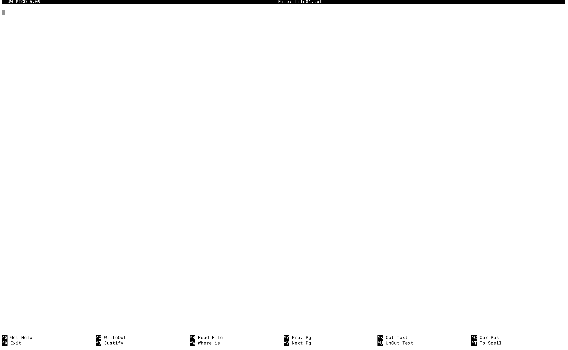 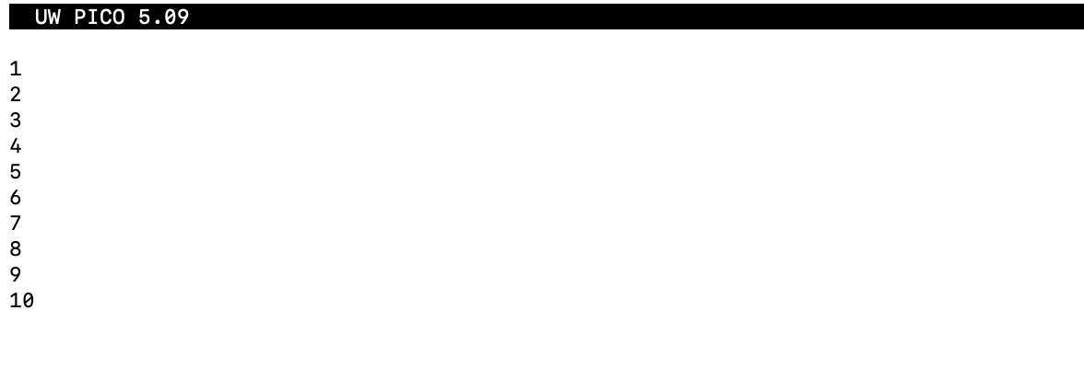

**Cameryns-MacBook-Air:shell_scripts cameryneickstead$ cat file01.txt file01.txt**  #display what is in the file

1

2

3

4

5

6

7

8

9

10

1

2

3

4

5

6

7

8

9

10

**Cameryns-MacBook-Air:shell_scripts cameryneickstead$ cat file01.txt** #display what is in the file

1

2

3

4

5

6

7

8

9

10

**Cameryns-MacBook-Air:shell_scripts cameryneickstead$ nano file02.txt txt** #create and edit an file

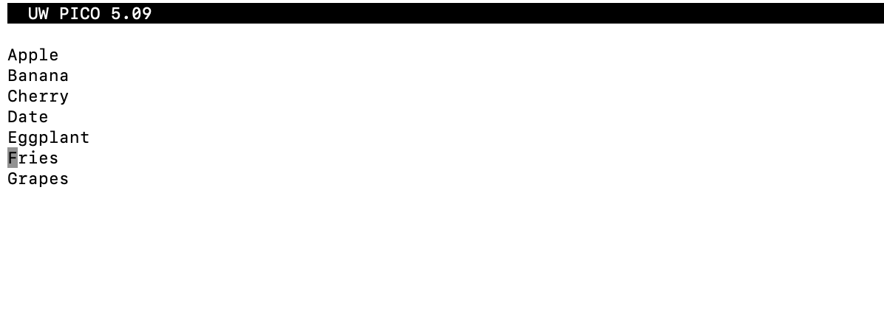

**Cameryns-MacBook-Air:shell_scripts cameryneickstead$ ls -F**

data/ file01.txt file02.txt results_1.txt.bkp src/

**Cameryns-MacBook-Air:shell_scripts cameryneickstead$ cat file01.txt file02.txt** #display what is in the file

1

2

3

4

5

6

7

8

9

10

Apple

Banana

Cherry

Date

Eggplant

Fries

Grapes

**Cameryns-MacBook-Air:shell_scripts cameryneickstead$ wc file02.txt** #display word and line count

7 7 47 file02.txt

**Cameryns-MacBook-Air:shell_scripts cameryneickstead$ nano file02.txt** #edit an existing file

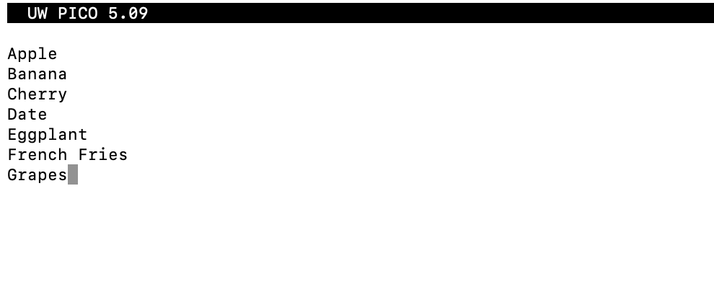

**Cameryns-MacBook-Air:shell_scripts cameryneickstead$ wc file02.txt**

7 8 54 file02.txt

**Cameryns-MacBook-Air:shell_scripts cameryneickstead$ wc -l file02.txt** #give only line count

7 file02.txt

**Cameryns-MacBook-Air:shell_scripts cameryneickstead$ wc -w file02.txt** #give only word count

8 file02.txt

**Cameryns-MacBook-Air:shell_scripts cameryneickstead$ wc -c file02.txt** #give only column count

54 file02.txt

**Cameryns-MacBook-Air:shell_scripts cameryneickstead$ ls -F**

data/ file01.txt file02.txt results_1.txt.bkp src/

**Cameryns-MacBook-Air:shell_scripts cameryneickstead$ wc file01.txt file02.txt**

10 10 21 file01.txt

7 8 54 file02.txt

17 18 75 total

**Cameryns-MacBook-Air:shell_scripts cameryneickstead$ wc *.txt** #use a wildcard – give counts for all files ending in .txt

10 10 21 file01.txt

7 8 54 file02.txt

17 18 75 total

**Cameryns-MacBook-Air:shell_scripts cameryneickstead$ cp file01.txt numbers.txt**

**Cameryns-MacBook-Air:shell_scripts cameryneickstead$ cp file02.txt foods.txt**

**Cameryns-MacBook-Air:shell_scripts cameryneickstead$ wc *.txt**

10 10 21 file01.txt

7 8 54 file02.txt

7 8 54 foods.txt

10 10 21 numbers.txt

34 36 150 total

**Cameryns-MacBook-Air:shell_scripts cameryneickstead$ wc f\*** #use a wildcard – give counts for all files starting with f

10 10 21 file01.txt

7 8 54 file02.txt

7 8 54 foods.txt

24 26 129 total

**Cameryns-MacBook-Air:shell_scripts cameryneickstead$ wc f*s.txt** #use a wildcard – give counts for all files starting with f and ending in s.txt

7 8 54 foods.txt

**Cameryns-MacBook-Air:shell_scripts cameryneickstead$ wc -l *.txt**

10 file01.txt

7 file02.txt

7 foods.txt

10 numbers.txt

34 total

**Cameryns-MacBook-Air:shell_scripts cameryneickstead$ wc -l *.txt > line_lengths.tmp**  #save word counts in file called line lengths

**Cameryns-MacBook-Air:shell_scripts cameryneickstead$ cat line_lengths.tmp** #show the contents of line lengths template

10 file01.txt

7 file02.txt

7 foods.txt

10 numbers.txt

34 total

**Cameryns-MacBook-Air:shell_scripts cameryneickstead$ sort line_lengths.tmp** #sort counts in ascending order of number of lines

7 file02.txt

7 foods.txt

10 file01.txt

10 numbers.txt

34 total

**Cameryns-MacBook-Air:shell_scripts cameryneickstead$ sort -n line_lengths.tmp** #sort counts in ascending order of number of lines

7 file02.txt

7 foods.txt

10 file01.txt

10 numbers.txt

34 total

**Cameryns-MacBook-Air:shell_scripts cameryneickstead$ sort -k 1 line_lengths.tmp** #sort counts by column 1

7 file02.txt

7 foods.txt

10 file01.txt

10 numbers.txt

34 total

**Cameryns-MacBook-Air:shell_scripts cameryneickstead$ sort -k1n,2 line_lengths.tmp** #sort counts by column and number of lines

7 file02.txt

7 foods.txt

10 file01.txt

10 numbers.txt

34 total

**Cameryns-MacBook-Air:shell_scripts cameryneickstead$ sort -n line_lengths.tmp > sorted_line_lengths.tmp** #save output of sorting into file called sorted line lengths

**Cameryns-MacBook-Air:shell_scripts cameryneickstead$ ls -F sorted_line_lengths.tmp**

**sorted_line_lengths.tmp**

**Cameryns-MacBook-Air:shell_scripts cameryneickstead$ tail sorted_line_lengths.tmp** #show the last 10 lines of the file – there are only 5 lines in this file, so all lines are shown

7 file02.txt

7 foods.txt

10 file01.txt

10 numbers.txt

34 total

**Cameryns-MacBook-Air:shell_scripts cameryneickstead$ tail -n1 sorted_line_lengths.tmp**  #show the last line of the file

34 total

**Cameryns-MacBook-Air:shell_scripts cameryneickstead$ wc -l *.txt**

10 file01.txt

7 file02.txt

7 foods.txt

10 numbers.txt

34 total

**Cameryns-MacBook-Air:shell_scripts cameryneickstead$ wc -l *.txt | sort -n**  #combine commands into a pipeline using the | (pipe) key

7 file02.txt

7 foods.txt

10 file01.txt

10 numbers.txt

34 total

**Cameryns-MacBook-Air:shell_scripts cameryneickstead$ wc -l *.txt | sort -n | tail -n1**

34 total

**Cameryns-MacBook-Air:shell_scripts cameryneickstead$ cd src/**

**Cameryns-MacBook-Air:src cameryneickstead$ nano script.sh**

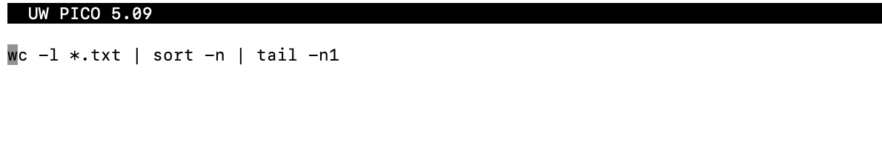**Cameryns-MacBook-Air:src cameryneickstead$ cat script.sh**

wc -l *.txt | sort -n | tail -n1

**Cameryns-MacBook-Air:src cameryneickstead$ bash script.sh**  #run a script

wc: *.txt: open: No such file or directory

**Cameryns-MacBook-Air:src cameryneickstead$ ls -F**

script.sh

**Cameryns-MacBook-Air:src cameryneickstead$ nano script.sh**

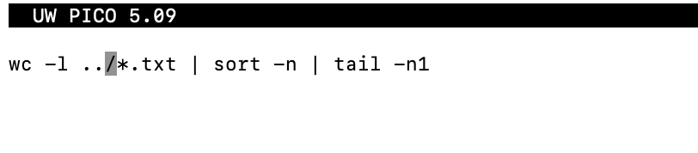

**Cameryns-MacBook-Air:src cameryneickstead$ bash script.sh**

wc: ../data/*.txt: open: No such file or directory

**Cameryns-MacBook-Air:src cameryneickstead$ nano script.sh**

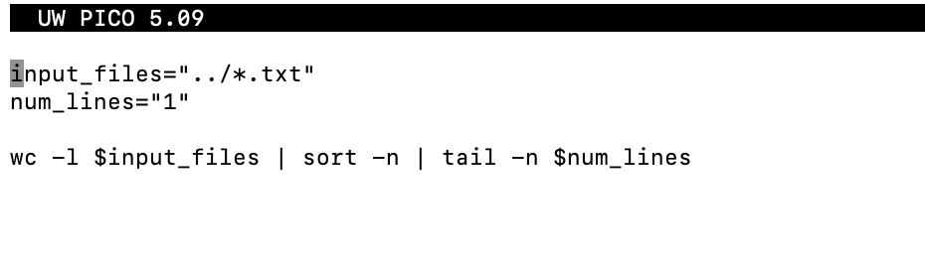**Cameryns-MacBook-Air:src cameryneickstead$ bash script.sh**

34 total

**Cameryns-MacBook-Air:src cameryneickstead$ nano script.sh**

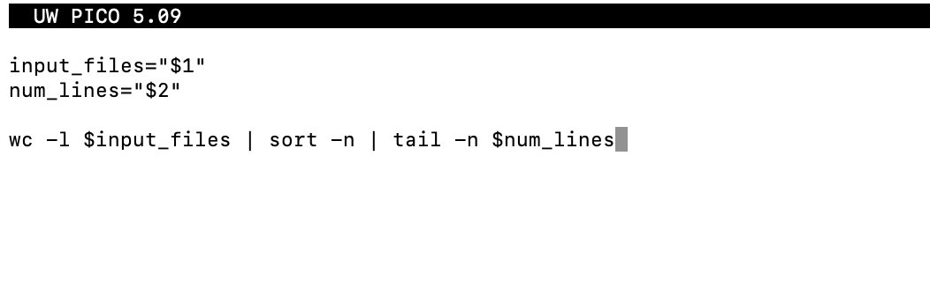**Cameryns-MacBook-Air:src cameryneickstead$ bash script.sh**

tail: option requires an argument -- n

usage: tail [-F | -f | -r] [-q] [-b # | -c # | -n #] [file ...]

**^C** #cancel a job

**Cameryns-MacBook-Air:src cameryneickstead$ bash script.sh "../*.txt" "1"** #run the script using all files ending in .txt and display last line

34 total

**Cameryns-MacBook-Air:src cameryneickstead$ bash script.sh "../f*" "3"**  #run the script with all files starting with f and display the last 3 lines

7 ../foods.txt

10 ../file01.txt

24 total

**Cameryns-MacBook-Air:src cameryneickstead$ nano script.sh**

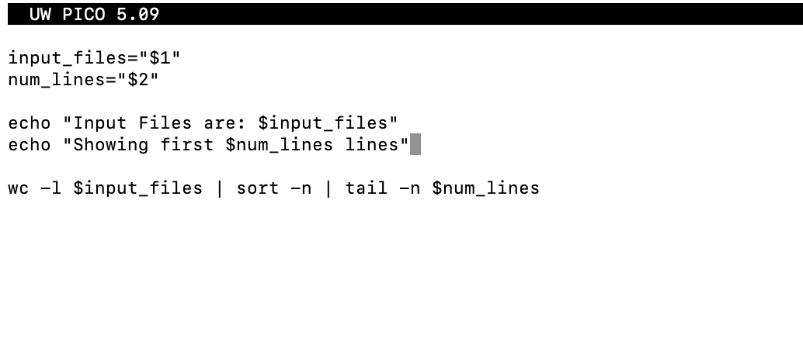**Cameryns-MacBook-Air:src cameryneickstead$ cat script.sh**

input_files="$1"

num_lines="$2"

echo "Input Files are: $input_files"

echo "Showing first $num_lines lines"

wc -l $input_files | sort -n | tail -n $num_lines

**Cameryns-MacBook-Air:src cameryneickstead$ bash script.sh "../*.txt" "1"**

Input Files are: ../*.txt

Showing first 1 lines

34 total

Shortcuts:

You can run an old line of code using the up and down arrows.

If you don’t want to write a whole file/direc name, you can write the first few characters and press tab, and it will autofill.

**Version Control with Git**

What is Version Control?

* Software that tracks and organizes changes to files over time
* Serves as a lab notebook for coding
  + Tracks changes over time
    - Adding changed files to keep track of all past version
    - Can “commit” the changes, so they remain and are saved
  + Keeps a full shared history
    - Sharable to a repository
  + Complements peer review
    - Repositories sync across multiple computers, and multiple people can contribute to changes – everyone will have the latest copy
  + Works offline
    - Syncs changes when you connect back to internet
    - Can choose when to push changes

Why use Version Control?

* Nothing committed is ever lost
* Can know who makes what changes
* Automatic merging

Git Creation:

* Click create repository
  + Type name and description
  + Add readme file
  + Choose .gitignore file type
* Click the Code dropdown, select ssh, and copy the filepath to sync to your computer.
  + Paste the filepath in your local terminal/command center
  + Input your git username and password to verify

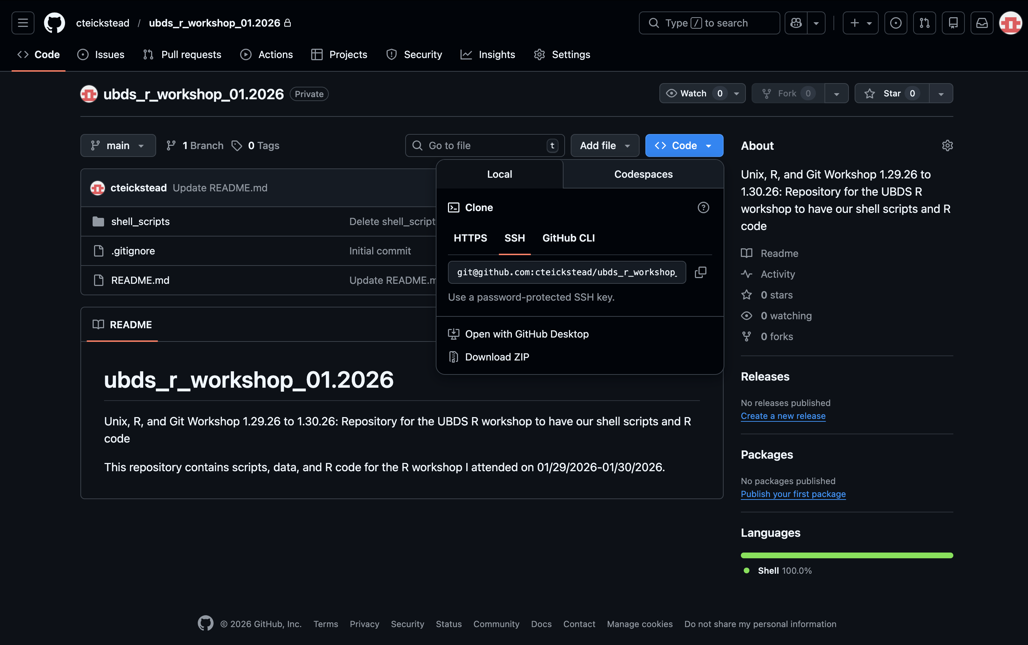

* Drag and drop directories/files into git repository

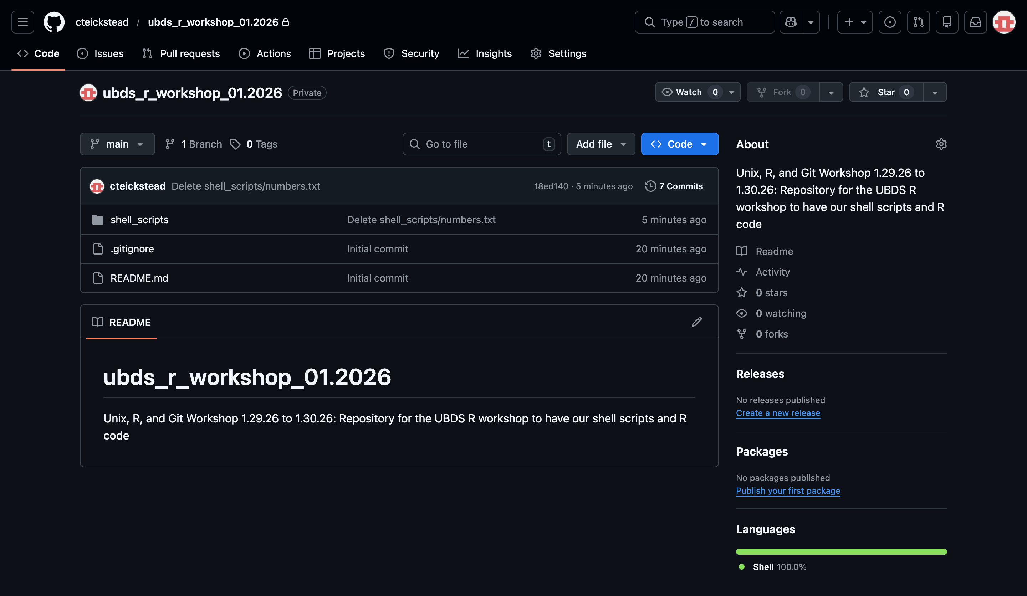

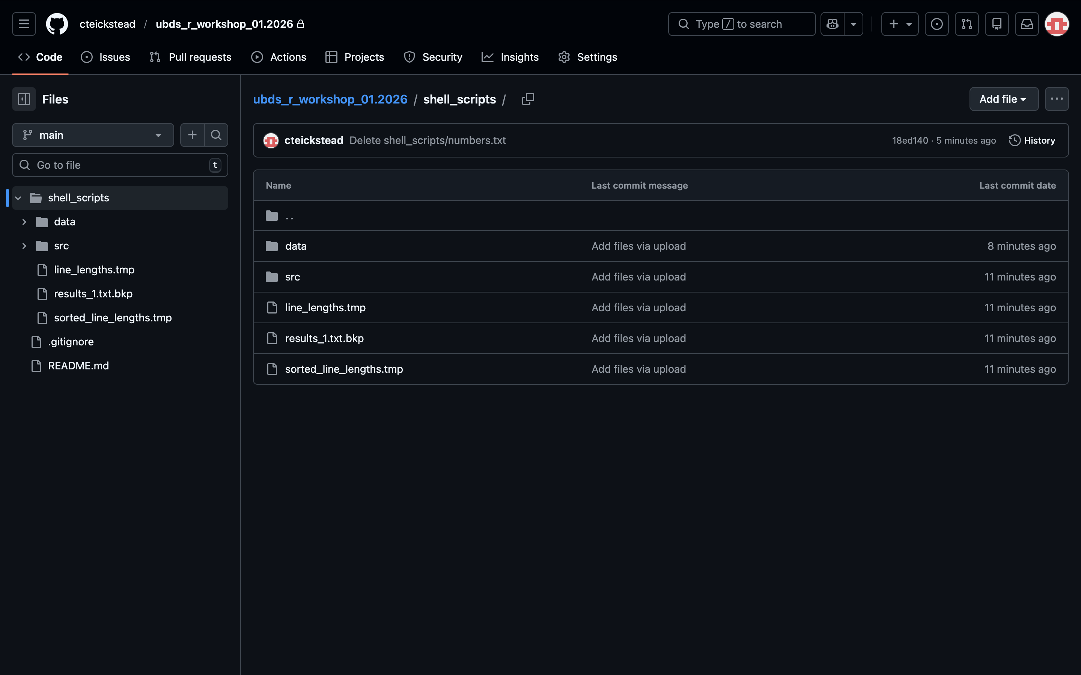

* Update README file
  + To get headers, write **## <Header>**
  + To get bullet points, write **- **<bullet info>/** -**
  + Click commit to save changes

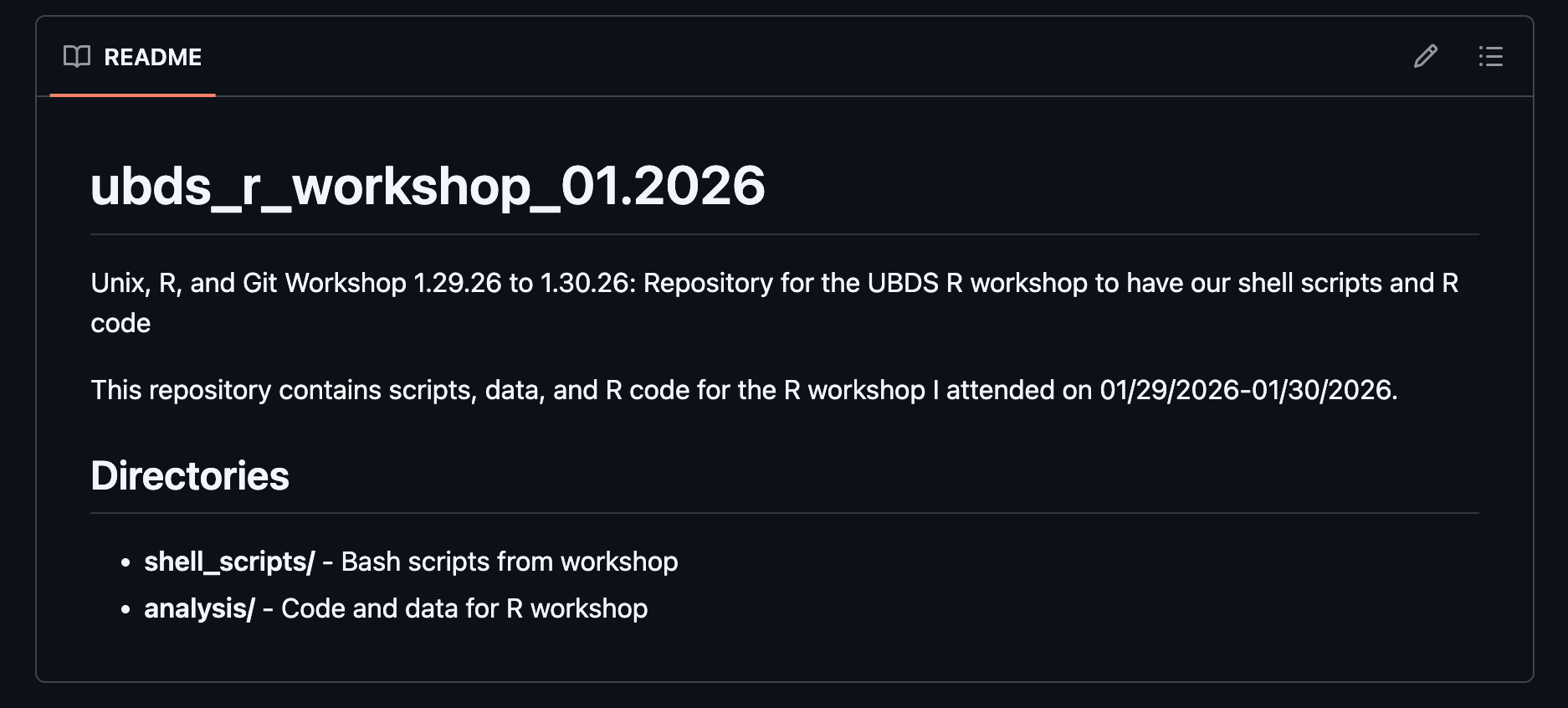

See my repository link for results: <https://github.com/cteickstead/ubds_r_workshop_01.2026>

**Introduction to R and RStudio**

Key terms

* IDE (Integrated development environment): all-in-one software
* Console: a tool where commands are written, and it responses to get tasks done
* Script: set of written code strung together
* Function: a reusable code that performs a specific task
* Open Source: source code is freely available for anyone to view, modify, and distribute
* Objects: containers that store data and functions
* Package: collection of code, functions, and datasets bundled together for specific tasks
* Operator: symbol or function in code that performs a specific mathematical or logical manipulation on data
* CRAN (Comprehensive R archive network): repository for R
* Dataframe: dataset that can be manipulated and analyzed in R
* Vectors: sequence of data elements of the same type
* Fuzzy search: technique for finding items that are approximately similar to a search term (like a wildcard in unix)

R/RStudio

* Programming environment for statistical computing and graphics
* Allows
  + Data analysis
  + Data visualization
  + Rapid development of new tools
  + Reproducibility
* Free and open resource

R Prep:

* Create a new project
  + Go to File > New Project > New Directory > New Project

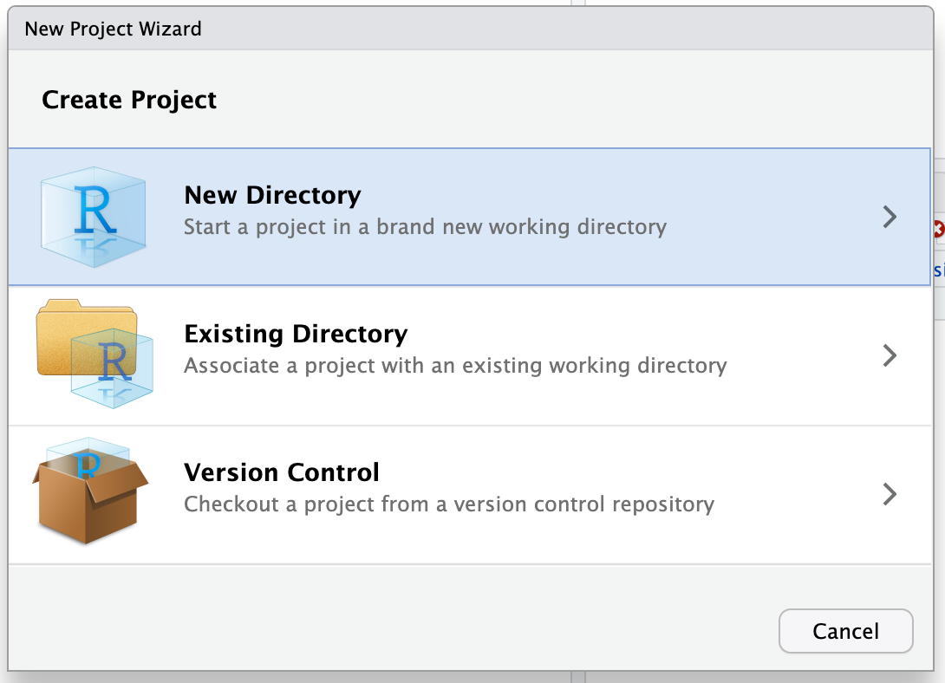

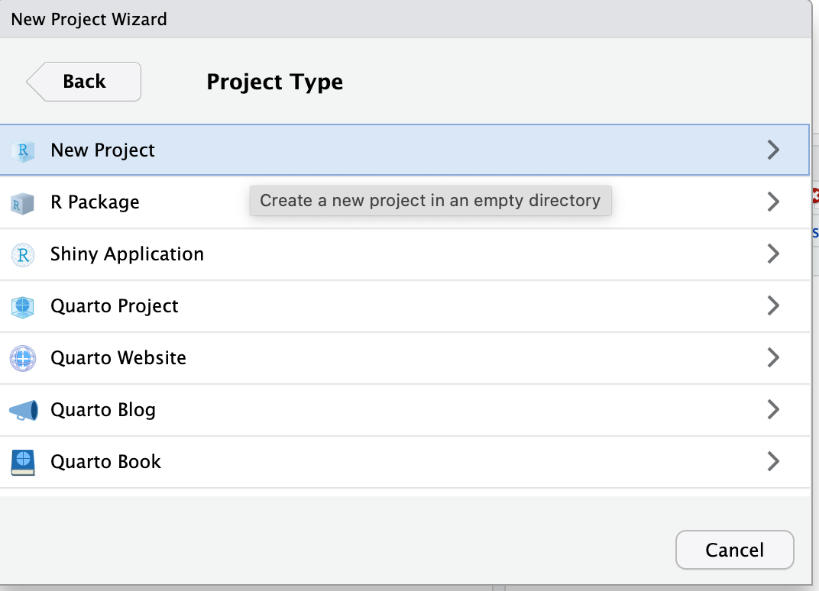

* + Fill in project name and link it to a folder using the “Browse” function

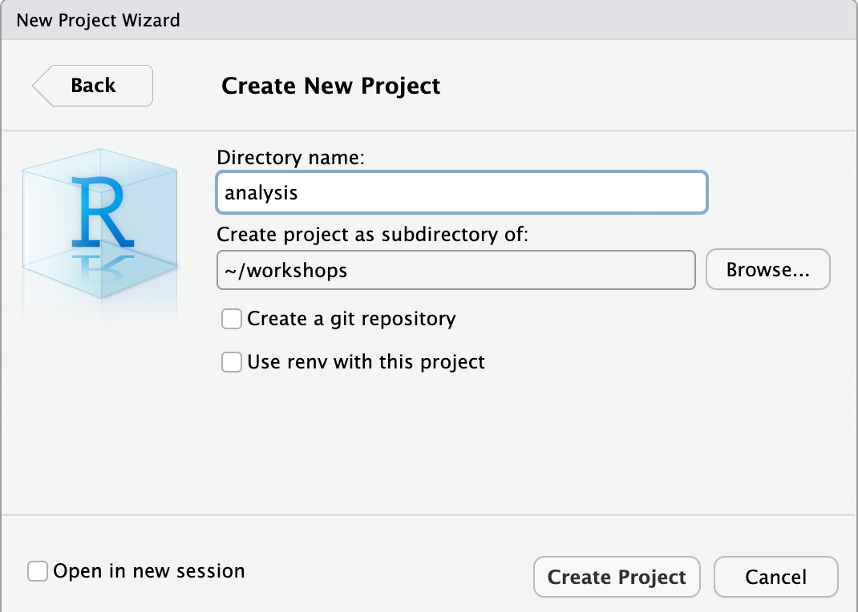

* Create a new script
  + Go to File > New File > R Script

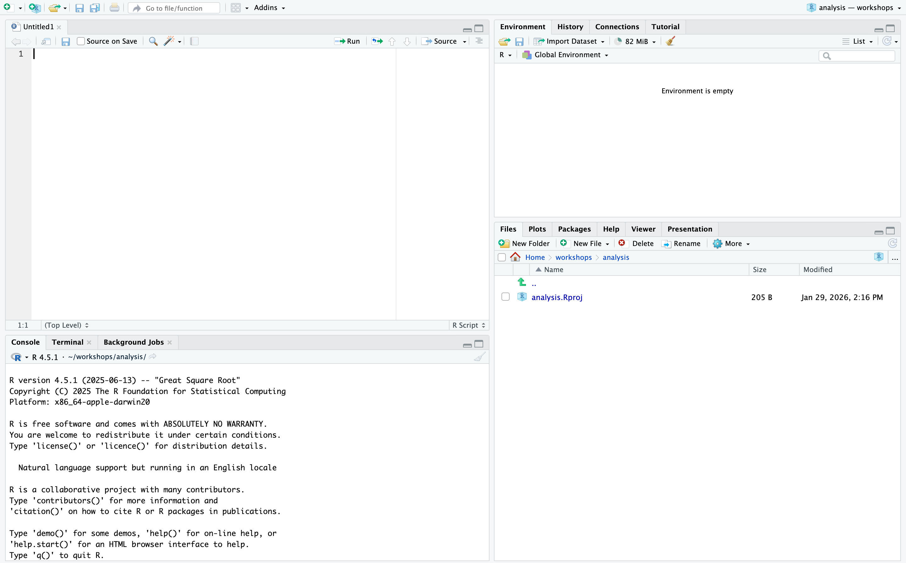

Code used today:

# identifying R version

R.version

# output: RStudio version 4.5.1 (2025-06-13)

# hashtags will create notes!

# example: this is a comment

100 + 101

# highlight the code and press control + enter to bring this line to the terminal and run it

# if you want to run the whole script at once, do not highlight anything - just press control + enter

# output: 201

# if you start a calculation and do not want to finish it, press control + c

123 +

#press control + C

# R automatically uses the order of operations (PEMDAS)

3 + 5 * 10

# output: 53

# no difference from before

3 + (5 * 10)

# output: 53

# you have to force the equation if you want the 3 and 5 added first

(3 + 5) * 10

# output: 80

# you have to use the asterisk if you want it to multiply - the version below gets an error

(3 + 5)10

# gives error

# exponents

3^2

# output: 9

# are these equal? - ONLY USE THIS TEST WITH INTEGERS because computers aren't great with decimals

10 == 10

# Tells me "True"

9 == 10

# Tells me "False"

10.01 == 10.01

# Tells me "True"

10.01 == 10.0000000000001

# Tells me "False"

10.0 == 10.00000000000000001

# Tells me "True," but we know there is a small difference

# working with fractions

2/1000

# output: 0.002

2/10000

# output: 2e-14

500000000/2

# output: 2.5e+08 - R likes scientific notation

# R HAS FUNCTIONS

# tells you what directory you're in

getwd()

# output: "/Users/cameryneickstead/workshops/analysis"

# do trigonometry

# list all variables

ls()

# output: [1] "q" "x" "z"

sin(1)

# output: 0.841471 - not sure if it is in degrees or radians

?sin # to get more information, write this code, and it will give you a help-sheet on the side

# info from the help sheet: angles are in radians, not degrees

# adding variables

# use an arrow to set the variable equal to an equation

x <- 1/40

# R will track the variable "x" on your environment

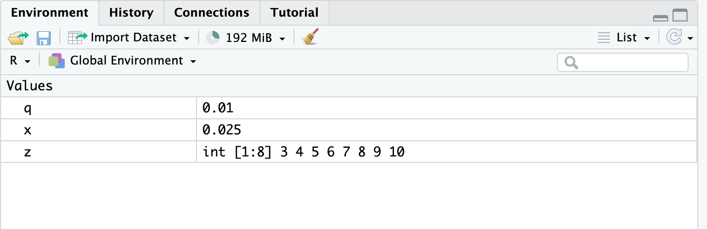

# output: 0.025

# can also use an equal sign, but it's more common to use an arrow

q = 1/100

# output: 0.01

?"<-" # get more information as to why R uses arrows

# using vectors

# create a vector

1:5

# output: [1] 1 2 3 4 5

# set variable as vector

z <- 3:10

# output shows up in environment: int [1:8] 3 4 5 6 7 8 9 10

# vectors in computations

2^(z)

# output: [1] 8 16 32 64 128 256 512 1024

#deleting variables

rm(x)

# installing packages - I did not do this, because I already have these packages installed

install.packages("tidyverse")

install.packages("dplyr")

# loading packages

library(tidyverse)

library(dplyr)

**Project Management with R: Seeking Help**

Make sure to save all files in organized folder system so that anyone can go into the folder and figure out what you’re doing

**Data Structures**

Code used today:

# data structures and types

# there are 5 data types in R

# type 1: a double

double_var <- 3.14

# verify the type

typeof(double_var)

# output: [1] "double"

double_var_2 <-1

typeof(double_var_2)

# output: [1] "double"

#type 2: an integer

int_var <- 4L # L forces the variable to be a whole number

typeof(int_var)

# output: [1] "integer"

# type 3: complex

complex_var <- 1 + 1i

typeof(complex_var)

# output: [1] "complex"

# type 4: logical - True or False

logical_var <- TRUE

typeof(logical_var)

# output: [1] "logical"

# type 5: character

char_var <- "This is a Character"

typeof(char_var)

# output: [1] "character"

# calculations using these data

45 * TRUE

# output: 45

45 + "word"

# gives an error because the data are non-numeric

5 * a

# gives an error because the variable doesn't exist

# Collections and Vectors

# create a vector

my_vector <- vector(length = 3)

# output in environment: logi [1:3] FALSE FALSE FALSE

another_vector <- vector(mode='character', length=3)

# output in environment: chr [1:3] "" "" ""

str(another_vector)

# output: chr [1:3] "" "" ""

#list the first value

another_vector[1]

# output: [1] ""

# combine values into vector

double_vector <- c(5, 7, 9)

# output in environment: num [1:3] 5 7 9

double_vector[3]

# output: [1] 9

# change values in a vector by index

double_vector[1] <- 13

# output in environment: num [1:3] 13 7 9

# define vectors with multiple data types

multi_vector <- c(2, 6, '3')

# output in environment: chr [1:3] "2" "6" "3"

# forces all values to be the same type of data

coercion_vector <- c('a', TRUE)

# output in environment: chr [1:2] "a" "TRUE"

# coerces all data to be the same type

# type coersion flow: Logical > Integer > Double > Complex > Character - cannot go backwards

another_coersion_vector <- c(4, TRUE)

# output in environment: num [1:2] 4 1 - TRUE=1 and FALSE=0

# going against the coersion flow

character_vector <- c('0', '2', '4')

# output in environment: chr [1:3] "0" "2" "4"

converted_vector <- as.double(character_vector)

# output in environment: num [1:3] 0 2 4

#Lists

list_example <- list(1, "a", TRUE, 1+4i)

# accessing the lists - example of wrong way to do it

list_example

# output: [[1]]

# [1] 1

# [[2]]

# [1] "a"

# [[3]]

#[1] TRUE

#[[4]]

#[1] 1+4i

# lists are accessed a little differently - the correct way to do it

list_example[[2]]

# output: [1] "a"

# add metadata to lists

another_list <- list(

title = "Numbers",

numbers = 1:10,

data = TRUE

)

another_list

# output: $title

# [1] "Numbers"

# $numbers

# [1] 1 2 3 4 5 6 7 8 9 10

# $data

# [1] TRUE

another_list$title

# output: [1] "Numbers"

another_list$numbers

# output: [1] 1 2 3 4 5 6 7 8 9 10

str(another_list$numbers)

# output: int [1:10] 1 2 3 4 5 6 7 8 9 10

#Matrix

matrix_example <- matrix(0, nrow=6, ncol=3)

matrix_example

# output: [,1] [,2] [,3]

# [1,] 0 0 0

# [2,] 0 0 0

# [3,] 0 0 0

# [4,] 0 0 0

# [5,] 0 0 0

# [6,] 0 0 0

dim(matrix_example)

# output: [1] 6 3

typeof(matrix_example)

# output: [1] "double"

nrow(matrix_example)

# output: [1] 6

ncol(matrix_example)

# output: [1] 3

matrix_example[1,1]

# output: [1] 0

matrix_example + 2

# output: [,1] [,2] [,3]

# [1,] 2 2 2

# [2,] 2 2 2

# [3,] 2 2 2

# [4,] 2 2 2

# [5,] 2 2 2

# [6,] 2 2 2

matrix_example_2 <- matrix_example + 2

matrix_example_2

# output: [,1] [,2] [,3]

# [1,] 2 2 2

# [2,] 2 2 2

# [3,] 2 2 2

# [4,] 2 2 2

# [5,] 2 2 2

# [6,] 2 2 2

matrix_example_2 * matrix_example_2

# output: [,1] [,2] [,3]

# [1,] 4 4 4

# [2,] 4 4 4

# [3,] 4 4 4

# [4,] 4 4 4

# [5,] 4 4 4

# [6,] 4 4 4

# Dataframes

"red"

cats <- data.frame(

coat = c("calico", "black", "tabby"),

weight = c(2.1, 5.0, 3.2),

likes_catnip = c(1, 0, 1)

)

cats

# output coat weight likes_catnip

# 1 calico 2.1 1

# 2 black 5.0 0

# 3 tabby 3.2 1

typeof(cats)

# output: [1] "list"

str(cats)

# output: 'data.frame': 3 obs. of 3 variables:

# $ coat : chr "calico" "black" "tabby"

# $ weight : num 2.1 5 3.2

# $ likes_catnip: num 1 0 1

class(cats)

# output: [1] "data.frame"

# accessing columns by name

cats$weight

# output: [1] 2.1 5.0 3.2

cats$coat

# output: [1] "calico" "black" "tabby"

# performing operations

cats$weight + cats$likes_catnip

# output: [1] 3.1 5.0 4.2

cats$weight + 2

# output: [1] 4.1 7.0 5.2

cats$weight + "word"

# gives error - "word" is not numeric

paste("My cat is", cats$coat)

# output: [1] "My cat is calico" "My cat is black" "My cat is tabby"

typeof(cats$weight)

# output: [1] "double"

# adding a new row to data frame

additional_cat <- data.frame(

coat = "tabby",

weight = "2.3 or 2.4",

likes_catnip = 1

)

additional_cat

# output coat weight likes_catnip

# 1 tabby 2.3 or 2.4 1

combined_cats <- rbind(cats, additional_cat)

combined_cats

# output: coat weight likes_catnip

# 1 calico 2.1 1

# 2 black 5 0

# 3 tabby 3.2 1

# 4 tabby 2.3 or 2.4 1

typeof(cats$weight)

# output: [1] "double"

typeof(combined_cats$weight)

# output: [1] "character" - the additional cat had 2.3 or 2.4 as a value, which is a character

# accessing a data frame

cats[1,1]

# output: [1] "calico"

cats[,1] # gives first column

# output: [1] "calico" "black" "tabby"

cats[1,] # gives first row

# output: coat weight likes_catnip

# 1 calico 2.1 1

**Exploring Data Frames**

Code used today:

# Write data to a csv file

write.csv(cats, "data/feline-data.csv")

# read data frame to a variable

cats <- read.csv("data/feline-data.csv")

cats

# output: X coat weight likes_catnip

# 1 1 calico 2.1 1

# 2 2 black 5.0 0

# 3 3 tabby 3.2 1

# add new column

age <- c(2,3,5)

cbind(cats, age)

# output: X coat weight likes_catnip age

# 1 1 calico 2.1 1 2

# 2 2 black 5.0 0 3

# 3 3 tabby 3.2 1 5

nrow(cats)

# output: [1] 3

length(age)

# output: [1] 3

# add new row

newRow <- list("tortoiseshell", 3.3, TRUE, 9)

newRow

# output: [[1]]

[1] "tortoiseshell"

[[2]]

[1] 3.3

[[3]]

[1] TRUE

[[4]]

[1] 9

cats <- rbind(cats, newRow)

cats[-4,] # remove 4th row

# output: X coat weight likes_catnip

# 1 1 calico 2.1 1

# 2 2 black 5.0 0

# 3 3 tabby 3.2 1

cats[,-4] # remove 4th column

# output: X coat weight

# 1 1 calico 2.1

# 2 2 black 5.0

# 3 3 tabby 3.2

# 4 tortoiseshell 3.3 1.0

names(cats)

# output: [1] "X" "coat" "weight" "likes_catnip"

drop <- names(cats) %in% c("age")

drop

# output: [1] FALSE FALSE FALSE FALSE - something went wrong, look into it with code below

cats[, !drop]

# output: X coat weight likes_catnip

# 1 1 calico 2.1 1

# 2 2 black 5.0 0

# 3 3 tabby 3.2 1

# 4 tortoiseshell 3.3 1.0 9

!drop

# output: [1] TRUE TRUE TRUE TRUE

# append two data frames

cats <- rbind(cats, cats)

cats

# output: X coat weight likes_catnip

# 1 1 calico 2.1 1

# 2 2 black 5.0 0

# 3 3 tabby 3.2 1

# 4 tortoiseshell 3.3 1.0 9

# 5 1 calico 2.1 1

# 6 2 black 5.0 0

# 7 3 tabby 3.2 1

# 8 tortoiseshell 3.3 1.0 9

df <- data.frame(

first_name = c("Cameryn", "John"),

last_name = c("Eickstead", "Doe"),

lucky_number = c(8, 13)

)

df

# output: first_name last_name lucky_number

# 1 Cameryn Eickstead 8

# 2 John Doe 13

# download a data set

download.file("https://raw.githubusercontent.com/swcarpentry/r-novice-gapminder/main/episodes/data/gapminder_data.csv", destfile = "data/gapminder_data.csv")

gapminder <- read.csv("data/gapminder_data.csv")

str(gapminder)

# output: 'data.frame': 1704 obs. of 6 variables:

$ country : chr "Afghanistan" "Afghanistan" "Afghanistan" "Afghanistan" ...

$ year : int 1952 1957 1962 1967 1972 1977 1982 1987 1992 1997 ...

$ pop : num 8425333 9240934 10267083 11537966 13079460 ...

$ continent: chr "Asia" "Asia" "Asia" "Asia" ...

$ lifeExp : num 28.8 30.3 32 34 36.1 ...

$ gdpPercap: num 779 821 853 836 740 ...

summary(gapminder)

# output: country year pop continent lifeExp

Length:1704 Min. :1952 Min. :6.001e+04 Length:1704 Min. :23.60

Class :character 1st Qu.:1966 1st Qu.:2.794e+06 Class :character 1st Qu.:48.20

Mode :character Median :1980 Median :7.024e+06 Mode :character Median :60.71

Mean :1980 Mean :2.960e+07 Mean :59.47

3rd Qu.:1993 3rd Qu.:1.959e+07 3rd Qu.:70.85

Max. :2007 Max. :1.319e+09 Max. :82.60

gdpPercap

Min. : 241.2

1st Qu.: 1202.1

Median : 3531.8

Mean : 7215.3

3rd Qu.: 9325.5

Max. :113523.1

typeof(gapminder$country)

# output: [1] "character"

typeof(gapminder$year)

# output: [1] "integer"

str(gapminder$year)

# output: int [1:1704] 1952 1957 1962 1967 1972 1977 1982 1987 1992 1997 ...

str(gapminder$continent)

# output: chr [1:1704] "Asia" "Asia" "Asia" "Asia" "Asia" "Asia" "Asia" "Asia" "Asia" "Asia" "Asia" ...

nrow(gapminder)

# output: [1] 1704

ncol(gapminder)

# output: [1] 6

dim(gapminder)

# output: [1] 1704 6

names(gapminder)

# output: [1] "country" "year" "pop" "continent" "lifeExp" "gdpPercap"

colnames(gapminder)

# output: [1] "country" "year" "pop" "continent" "lifeExp" "gdpPercap"

length(gapminder)

# output: [1] 6

head(gapminder)

# output: country year pop continent lifeExp gdpPercap

# 1 Afghanistan 1952 8425333 Asia 28.801 779.4453

# 2 Afghanistan 1957 9240934 Asia 30.332 820.8530

# 3 Afghanistan 1962 10267083 Asia 31.997 853.1007

# 4 Afghanistan 1967 11537966 Asia 34.020 836.1971

# 5 Afghanistan 1972 13079460 Asia 36.088 739.9811

# 6 Afghanistan 1977 14880372 Asia 38.438 786.1134

head(gapminder, n = 10)

# output: country year pop continent lifeExp gdpPercap

# 1 Afghanistan 1952 8425333 Asia 28.801 779.4453

# 2 Afghanistan 1957 9240934 Asia 30.332 820.8530

# 3 Afghanistan 1962 10267083 Asia 31.997 853.1007

# 4 Afghanistan 1967 11537966 Asia 34.020 836.1971

# 5 Afghanistan 1972 13079460 Asia 36.088 739.9811

# 6 Afghanistan 1977 14880372 Asia 38.438 786.1134

# 7 Afghanistan 1982 12881816 Asia 39.854 978.0114

# 8 Afghanistan 1987 13867957 Asia 40.822 852.3959

# 9 Afghanistan 1992 16317921 Asia 41.674 649.3414

# 10 Afghanistan 1997 22227415 Asia 41.763 635.3414

tail(gapminder)

# output: country year pop continent lifeExp gdpPercap

# 1699 Zimbabwe 1982 7636524 Africa 60.363 788.8550

# 1700 Zimbabwe 1987 9216418 Africa 62.351 706.1573

# 1701 Zimbabwe 1992 10704340 Africa 60.377 693.4208

# 1702 Zimbabwe 1997 11404948 Africa 46.809 792.4500

# 1703 Zimbabwe 2002 11926563 Africa 39.989 672.0386

# 1704 Zimbabwe 2007 12311143 Africa 43.487 469.7093

**Day 2**

**Subsetting Data**

Code used today:

# creating a vector

x <- c(3,4,6,7,8)

x

# output: [1] 3 4 6 7 8

#naming a vector

names(x) <- c("a","b","c","d","e")

x

# output: a b c d e

# 3 4 6 7 8

# accessing value by index

x[1]

# output: a

# 3

x[3:5]

# output: c d e

# 6 7 8

x[c(3,4,5)]

# output: c d e

# 6 7 8

x[7]

# output: <NA>

# NA - we only have 5 indices, so it can't access the 7th index

x[0]

# output: named numeric(0) - cannot have a 0th index

# negative indices

x[-2]

# output: a c d e

# 3 6 7 8

x[c(-1,-5)]

# output: b c d

# 4 6 7

x[-1:5]

# gives error because there may be a 0 included

-1:5

# output: [1] -1 0 1 2 3 4 5

c(-1,-5)

# output: [1] -1 -5

# saving sliced vectors

x <- x[-4]

x

# output: a b c e

# 3 4 6 8

x <- c(1.1, 2.5, 6.4, 8.7)

names(x) <- c("a", "b","c","d")

x

# output: a b c d

# 1.1 2.5 6.4 8.7

# solution

x[1:2]

# output: a b

# 1.1 2.5

x[c(-3.-4)]

# output: a b c d

# 1.1 2.5 6.4 8.7

x[c(1,2)]

#output: a b

# 1.1 2.5

# access values from x

x[c("a","c")]

# output: a c

# 1.1 6.4

# access the values from x using logical value (TRUE/FALSE)

x[c("TRUE","FALSE","TRUE","FALSE")]

x

# output: <NA> <NA> <NA> <NA>

# NA NA NA NA

# soulution

x[c(TRUE,FALSE,TRUE,FALSE)]

x

# output: a b c d

# 1.1 2.5 6.4 8.7

# subsetting using logical operators ( <, >, ==)

x > 5

# output: a b c d

# FALSE FALSE TRUE TRUE - tells you which cases are greater than 5

x[x>5]

# output: c d

# 6.4 8.7 - gives you the values that are biiger than 5

x[x<2]

# output: a

# 1.1

x[x == 2]

# output: named numeric(0) - no values are ==2

x[x == 2.5]

# output: b

# 2.5

names(x) == "c"

# output: [1] FALSE FALSE TRUE FALSE - tells you which variable is named c

x[names(x) == "c"]

# output: c

# 6.4 - tells you the value of c

# more logical operators & and !

# using & (and) operator

x > 2 & x < 8

# output: a b c d

# FALSE TRUE TRUE FALSE

x[x>2 & x<8]

# output: b c

# 2.5 6.4

#using ! (not) operator

x > 2

# output: a b c d

# FALSE TRUE TRUE TRUE

!x>2

# output: a b c d

# TRUE FALSE FALSE FALSE

x[x>2]

# output: b c d

# 2.5 6.4 8.7

x[!x>2]

# output: a

# 1.1

# all() and any()

all(x>2)

# output: [1] FALSE

any(x>2)

# output: [1] TRUE

# non-unique names

x <- 1:8

x

# output: [1] 1 2 3 4 5 6 7 8

names(x) <- c("a","a","a","a","b","b","c","d")

x

# output: a a a a b b c d

# 1 2 3 4 5 6 7 8

x[names(x) == "a"]

# output; a a a a

# 1 2 3 4

# using - (negative) operator for names

x[-7]

# output: a a a a b b d

# 1 2 3 4 5 6 8 - can we do this with names?

x[-names(x)]

# this gives an error

x["a"]

# output: a

# 1

x[-"a"]

# also gives an error

x[!names(x) == "a"]

# output: b b c d

# 5 6 7 8 - this is the correct option

x[names(x) == c("a","d")]

# output: a a d

# 1 3 8 - why do only 2 of the a's show up?

x[!names(x) == c("a","d")]

# output: a a b b c

# 2 4 5 6 7 - why do 2 a's show up here?

x[names(x) != c("a","d")]

# output: a a b b c

# 2 4 5 6 7 - same here...2 a's show up??

# recycling variables

names(x) == c("a","d")

# output; [1] TRUE FALSE TRUE FALSE FALSE FALSE FALSE TRUE

length(names(x))

# output: [1] 8

length(c("a","d"))

# output; [1] 2

c("a","c","a","c","a","c","a","c")

names(x)

# output: [1] "a" "a" "a" "a" "b" "b" "c" "d"

names(x) == c("a","c")

# output: [1] TRUE FALSE TRUE FALSE FALSE FALSE FALSE FALSE

# %in% operator

names(x) %in% c("a","c")

# output: [1] TRUE TRUE TRUE TRUE FALSE FALSE TRUE FALSE

x[names(x) %in% c("a","c")]

# output: a a a a c

# 1 2 3 4 7

# data type: factors - so far we've been working with vectors

f <- factor(c("a","a","b","c","c","d"))

f

# output: [1] a a b c c d

# Levels: a b c d

f[f %in% c("b","c")]

# output: [1] b c c

# Levels: a b c d

f[-3]

# output: [1] a a c c d

# Levels: a b c d

# matrix

set.seed(1) # reproduce the same data when generating a matrix

m <- matrix(rnorm(6*4), ncol=4, nrow=6) # generates a random dataset, but it will be fixed with the code above

m

# output: [,1] [,2] [,3] [,4]

# [1,] -0.6264538 0.4874291 -0.62124058 0.82122120

# [2,] 0.1836433 0.7383247 -2.21469989 0.59390132

# [3,] -0.8356286 0.5757814 1.12493092 0.91897737

# [4,] 1.5952808 -0.3053884 -0.04493361 0.78213630

# [5,] 0.3295078 1.5117812 -0.01619026 0.07456498

# [6,] -0.8204684 0.3898432 0.94383621 -1.98935170

m[3:4,c(1,2)]

# output: [,1] [,2]

# [1,] -0.8356286 0.5757814

# [2,] 1.5952808 -0.3053884

m[3,]

# output: [1] -0.8356286 0.5757814 1.1249309 0.9189774

m[4,]

# output: [1] 1.59528080 -0.30538839 -0.04493361 0.78213630

m[3, ,drop = FALSE]

# output: [,1] [,2] [,3] [,4]

# [1,] -0.8356286 0.5757814 1.124931 0.9189774

m[6]

# output: [1] -0.8204684

m2 <- matrix(1:24, ncol=4, nrow=6)

m2

# output: [,1] [,2] [,3] [,4]

[1,] 1 7 13 19

[2,] 2 8 14 20

[3,] 3 9 15 21

[4,] 4 10 16 22

[5,] 5 11 17 23

[6,] 6 12 18 24

m2[8]

# output: [1] 8

m2 <- matrix(1:24, ncol=4, nrow=6, byrow = TRUE)

m2

# output: [,1] [,2] [,3] [,4]

# [1,] 1 2 3 4

# [2,] 5 6 7 8

# [3,] 9 10 11 12

# [4,] 13 14 15 16

# [5,] 17 18 19 20

# [6,] 21 22 23 24

m2[8]

# output: [1] 6

# list

head(mtcars)

# output: mpg cyl disp hp drat wt qsec vs am gear carb

# Mazda RX4 21.0 6 160 110 3.90 2.620 16.46 0 1 4 4

# Mazda RX4 Wag 21.0 6 160 110 3.90 2.875 17.02 0 1 4 4

# Datsun 710 22.8 4 108 93 3.85 2.320 18.61 1 1 4 1

# Hornet 4 Drive 21.4 6 258 110 3.08 3.215 19.44 1 0 3 1

# Hornet Sportabout 18.7 8 360 175 3.15 3.440 17.02 0 0 3 2

# Valiant 18.1 6 225 105 2.76 3.460 20.22 1 0 3 1

xlist <- list(a="Software Carpentry",

b=1:10,

data=head(mtcars)) #this dataset is preinstalled with R, you do not need to load it

xlist

# output: $a

#[1] "Software Carpentry"

# $b

# [1] 1 2 3 4 5 6 7 8 9 10

# $data

# mpg cyl disp hp drat wt qsec vs am gear carb

# Mazda RX4 21.0 6 160 110 3.90 2.620 16.46 0 1 4 4

# Mazda RX4 Wag 21.0 6 160 110 3.90 2.875 17.02 0 1 4 4

# Datsun 710 22.8 4 108 93 3.85 2.320 18.61 1 1 4 1

# Hornet 4 Drive 21.4 6 258 110 3.08 3.215 19.44 1 0 3 1

# Hornet Sportabout 18.7 8 360 175 3.15 3.440 17.02 0 0 3 2

# Valiant 18.1 6 225 105 2.76 3.460 20.22 1 0 3 1

xlist[1:2]

# output: $a

# [1] "Software Carpentry"

# $b

# [1] 1 2 3 4 5 6 7 8 9 10

xlist[[1:2]]

# gives an error

xlist[[2]]

# output: [1] 1 2 3 4 5 6 7 8 9 10

xlist[[2]][1]

# output: [1] 1

xlist[["a"]]

# output: [1] "Software Carpentry"

xlist[["b"]]

# output: [1] 1 2 3 4 5 6 7 8 9 10

xlist$data

# output: mpg cyl disp hp drat wt qsec vs am gear carb

# Mazda RX4 21.0 6 160 110 3.90 2.620 16.46 0 1 4 4

# Mazda RX4 Wag 21.0 6 160 110 3.90 2.875 17.02 0 1 4 4

# Datsun 710 22.8 4 108 93 3.85 2.320 18.61 1 1 4 1

# Hornet 4 Drive 21.4 6 258 110 3.08 3.215 19.44 1 0 3 1

# Hornet Sportabout 18.7 8 360 175 3.15 3.440 17.02 0 0 3 2

# Valiant 18.1 6 225 105 2.76 3.460 20.22 1 0 3 1

# subsetting a dataframe

head(gapminder)

# output: country year pop continent lifeExp gdpPercap

# 1 Afghanistan 1952 8425333 Asia 28.801 779.4453

# 2 Afghanistan 1957 9240934 Asia 30.332 820.8530

# 3 Afghanistan 1962 10267083 Asia 31.997 853.1007

# 4 Afghanistan 1967 11537966 Asia 34.020 836.1971

# 5 Afghanistan 1972 13079460 Asia 36.088 739.9811

# 6 Afghanistan 1977 14880372 Asia 38.438 786.1134

head(gapminder[["pop"]])

# output: [1] 8425333 9240934 10267083 11537966 13079460 14880372

head(gapminder[["pop"]], drop=FALSE)

# output: [1] 8425333 9240934 10267083 11537966 13079460 14880372

gapminder[,1:3]

# output will give you the first three columns of each participant (there's too much data for me to paste)

gapminder[gapminder$lifeExp > 80]

# gives an error - you specified the columns, but you're not accounting for the rows

gapminder[gapminder$lifeExp > 80,]

# output will list out the data for all participants who live past 80 (again, too much data to paste)

# not putting anything after the comma essentially means it will do it for everyone

**Control Flow**

Code used today:

# if statements

x <- 8

x

# output: [1] 8

if (x >= 10){

print("x is greater than or equal to 10")

}

# nothing is printed out...because 8 is not bigger than 10

# solution

if (x >= 10){

print("x is greater than or equal to 10")

} else {

print("x is less than 10")

}

# output: [1] "x is less than 10"

# if you have two true statements, use the code below

if (x >= 10){

print("x is greater than or equal to 10")

} else if (x > 5){

print("x is less than 10, but greater than 5")

} else {

print("x is lesser than or equal to 5")

}

# output: [1] "x is less than 10, but greater than 5"

# use logical values directly

x <- 4==3

x

# output: [1] FALSE

if(x) {

print("4 equals 3")

} else {

print("4 does not equal 3")

}

# output: [1] "4 does not equal 3"

# ifelse function

y <- -3

y

# output: [1] -3

ifelse(y < 0, "y is a negative number", "y is either zero or positive")

# output: [1] "y is a negative number"

# multiple logicals - any and all functions

x <- c(TRUE, TRUE, FALSE)

x

# output: [1] TRUE TRUE FALSE

if(x) {

print("x is true")

}

# gives you an error, looks at one single value at a time

# solution

if(any(x)) {

print("at least one value of x is true")

}

# output: [1] "at least one value of x is true"

if(all(x)) {

print("all of the values of x is true")

}

# does not give you an output because one value of x is false

# for loop - structured similarly to if statements

for (i in 1:10) {

print(i)

}

# output: [1] 1

# [1] 2

# [1] 3

# [1] 4

# [1] 5

# [1] 6

# [1] 7

# [1] 8

# [1] 9

# 1] 10 - gives you a single line for each vector

for (i in 1:5) {

for(j in c("a","b","c","d","e")) {

print(paste(i,j))

}

}

# output: [1] 1

# [1] 2

# [1] 3

# [1] 4

# [1] 5

# [1] 6

# [1] 7

# [1] 8

# [1] 9

# [1] 10

> for (i in 1:5) {

+ for(j in c("a","b","c","d","e")) {

+ print(paste(i,j))

+ }

+ }

# output: [1] "1 a"

# [1] "1 b"

# [1] "1 c"

# [1] "1 d"

# [1] "1 e"

# [1] "2 a"

# [1] "2 b"

# [1] "2 c"

# [1] "2 d"

# [1] "2 e"

# [1] "3 a"

# [1] "3 b"

# [1] "3 c"

# [1] "3 d"

# [1] "3 e"

# [1] "4 a"

# [1] "4 b"

# [1] "4 c"

# [1] "4 d"

# [1] "4 e"

# [1] "5 a"

# [1] "5 b"

# [1] "5 c"

# [1] "5 d"

# [1] "5 e"

output_vector <- c()

for (i in 1:5) {

for(j in c("a","b","c","d","e")) {

temp_output <- paste(i,j)

output_vector <- c(output_vector, temp_output)

}

}

output_vector

# output: [1] "1 a" "1 b" "1 c" "1 d" "1 e" "2 a" "2 b" "2 c" "2 d" "2 e" "3 a" "3 b" "3 c" "3 d" "3 e"

# [16] "4 a" "4 b" "4 c" "4 d" "4 e" "5 a" "5 b" "5 c" "5 d" "5 e"

# predefining the output size saves computational resources

output_matrix <- matrix(nrow=5, ncol=5) # predefining size

j_vector <- c("a","b","c","d","e")

for (i in 1:5) {

for(j in 1:5) {

temp_j_value <- j_vector[j]

temp_output <- paste(i, temp_j_value)

output_matrix[i,j] <- temp_output

}

}

output_matrix

# output: [,1] [,2] [,3] [,4] [,5]

# [1,] "1 a" "1 b" "1 c" "1 d" "1 e"

# [2,] "2 a" "2 b" "2 c" "2 d" "2 e"

# [3,] "3 a" "3 b" "3 c" "3 d" "3 e"

# [4,] "4 a" "4 b" "4 c" "4 d" "4 e"

# [5,] "5 a" "5 b" "5 c" "5 d" "5 e"

output_vector2 <-as.vector(output_matrix)

output_vector2

# output: [1] "1 a" "2 a" "3 a" "4 a" "5 a" "1 b" "2 b" "3 b" "4 b" "5 b" "1 c" "2 c" "3 c" "4 c" "5 c"

# [16] "1 d" "2 d" "3 d" "4 d" "5 d" "1 e" "2 e" "3 e" "4 e" "5 e"

# while loops - repeat a loop until something is no longer true

z <- 1

z

# output: [1] 1

while(z > 0.1) {

z <- runif(1)

cat(z, "\n") # forces every value to be pasted on a different line

}

# output: 0.7323137

# 0.6927316

# 0.4776196

# 0.8612095

# 0.4380971

# 0.2447973

# 0.07067905 - I got 7 values, but you may get something different. The instructor got 3 and said it would be different between people

**Creating Publication Quality Graphics with ggplot2**

What is ggplot2?

* R library for plotting data
* Publication-quality figures with customizability
* Multiple plotting systems
* Layered and reproducible

Code used today:

library(ggplot2)

gapminder <- read.csv("data/gapminder_data.csv")

ggplot(data = gapminder)

# plots will open on the righthand side

# nothing shows up with this code because we haven't added any elements

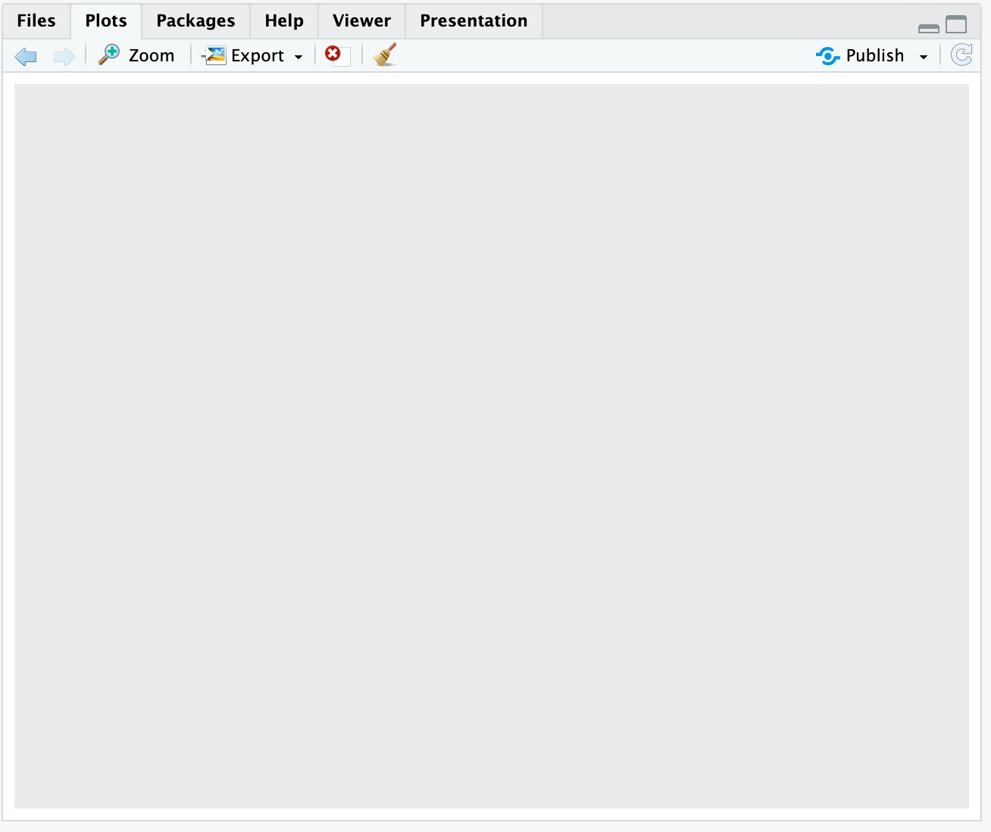

ggplot(data = gapminder, mapping = aes(x=gdpPercap, y=lifeExp)) # aes=aesthetics

# creates the x and y axes, but no data will show up yet - need to tell it how to show the data

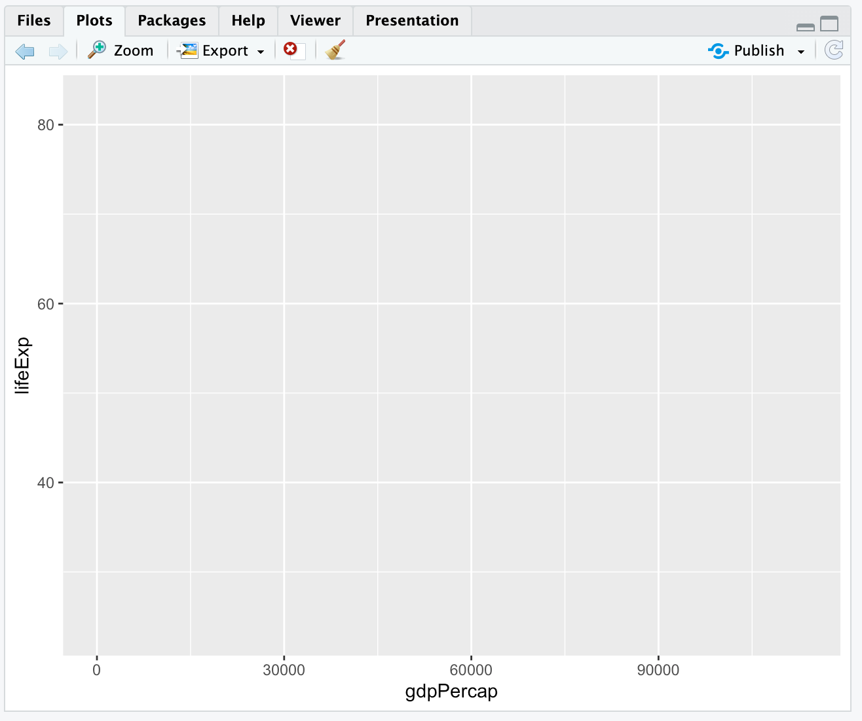

ggplot(data = gapminder, mapping = aes(x=gdpPercap, y=lifeExp)) + geom_point() # shows the data as well

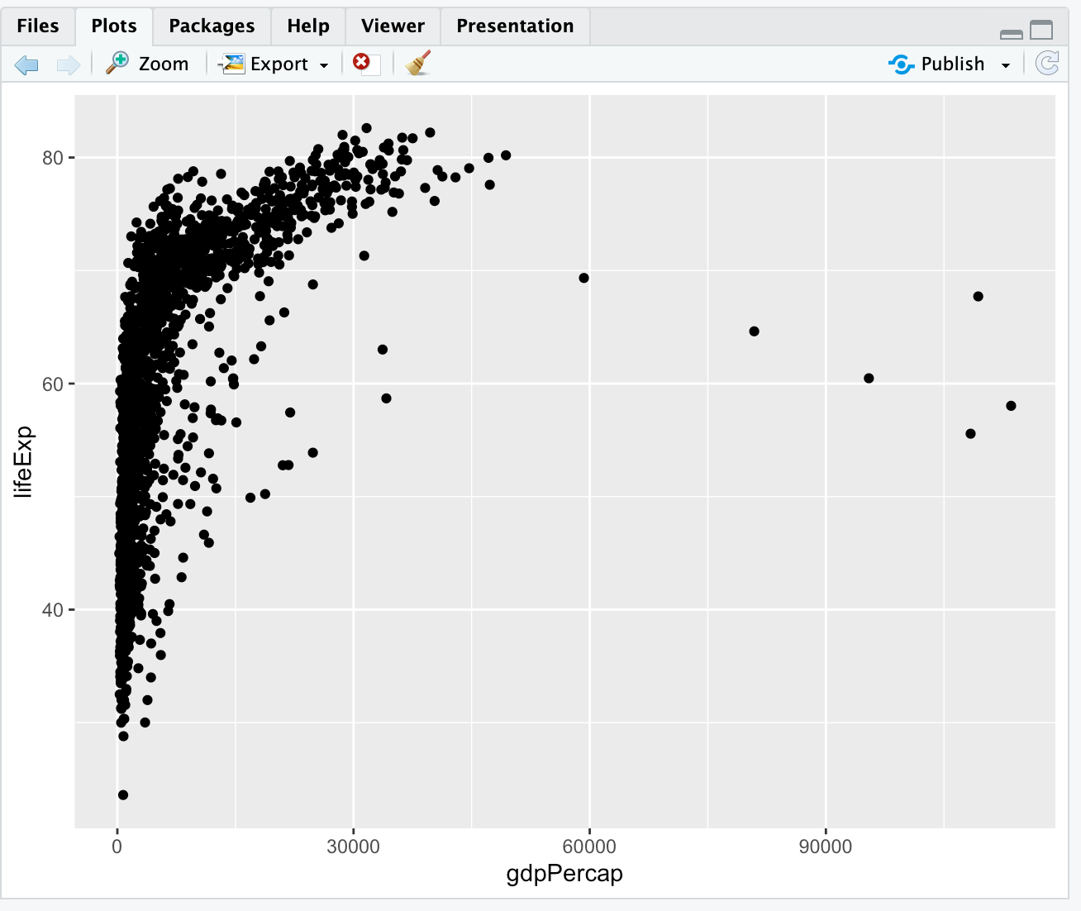

# changing x

ggplot(data = gapminder, mapping = aes(x=year, y=lifeExp)) +

geom_point()

# gives weird plot...data collected in one year

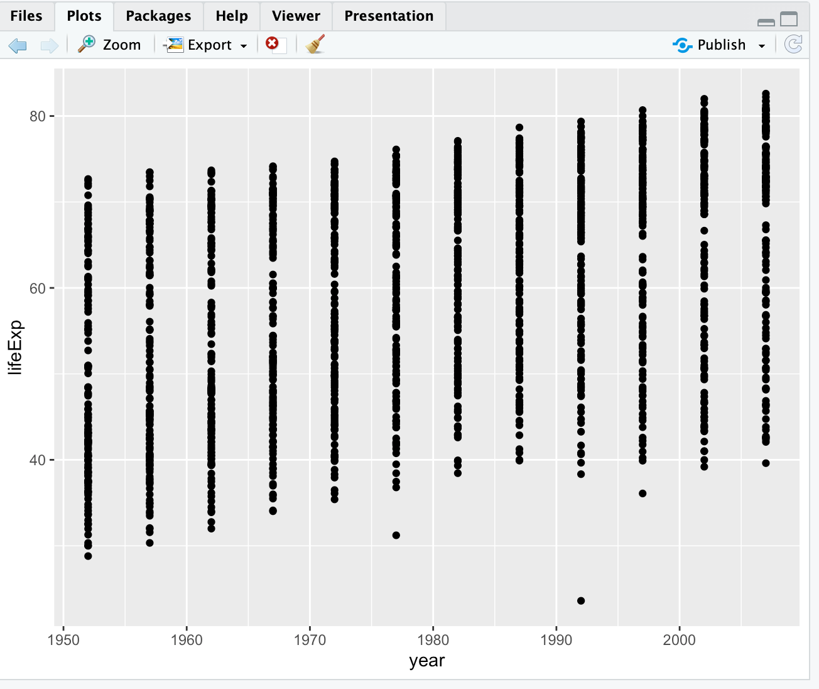

ggplot(data = gapminder, mapping = aes(x=year, y=lifeExp,

color = continent)) +

geom_line() # plotting line graphs, grouping colors by continent

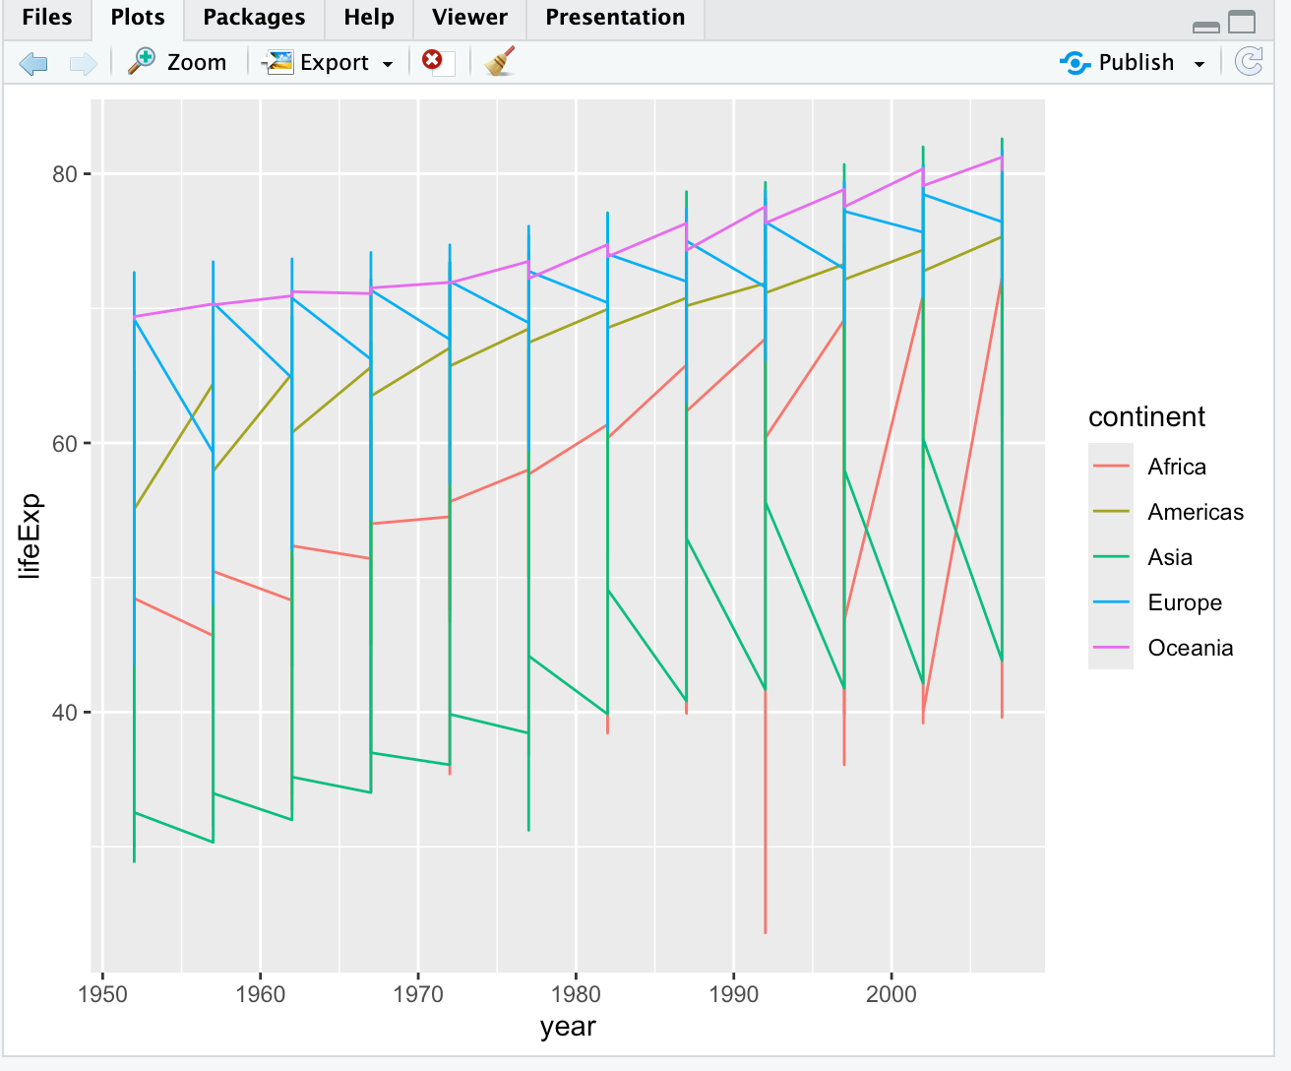

ggplot(data = gapminder, mapping = aes(x=year, y=lifeExp,

group = country, color = continent)) +

geom_line() # grouping by country

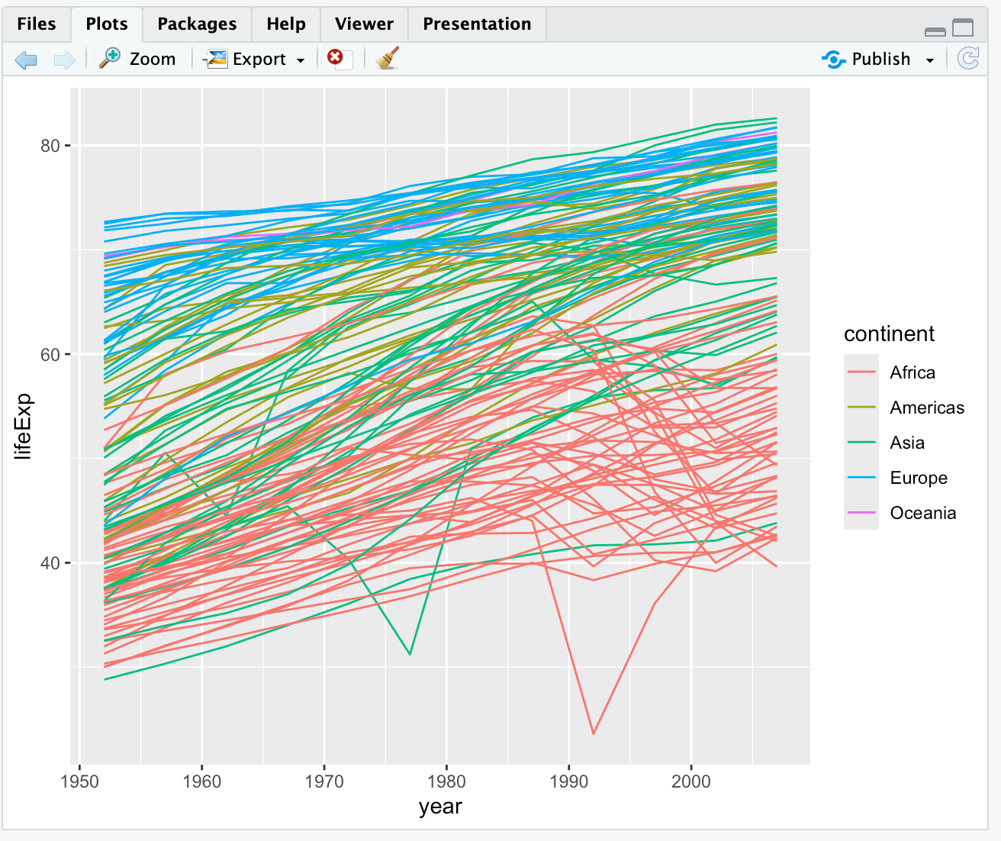

ggplot(data = gapminder, mapping = aes(x=year, y=lifeExp,

group = country, color = continent)) +

geom_line() + geom_point() # line and point graph

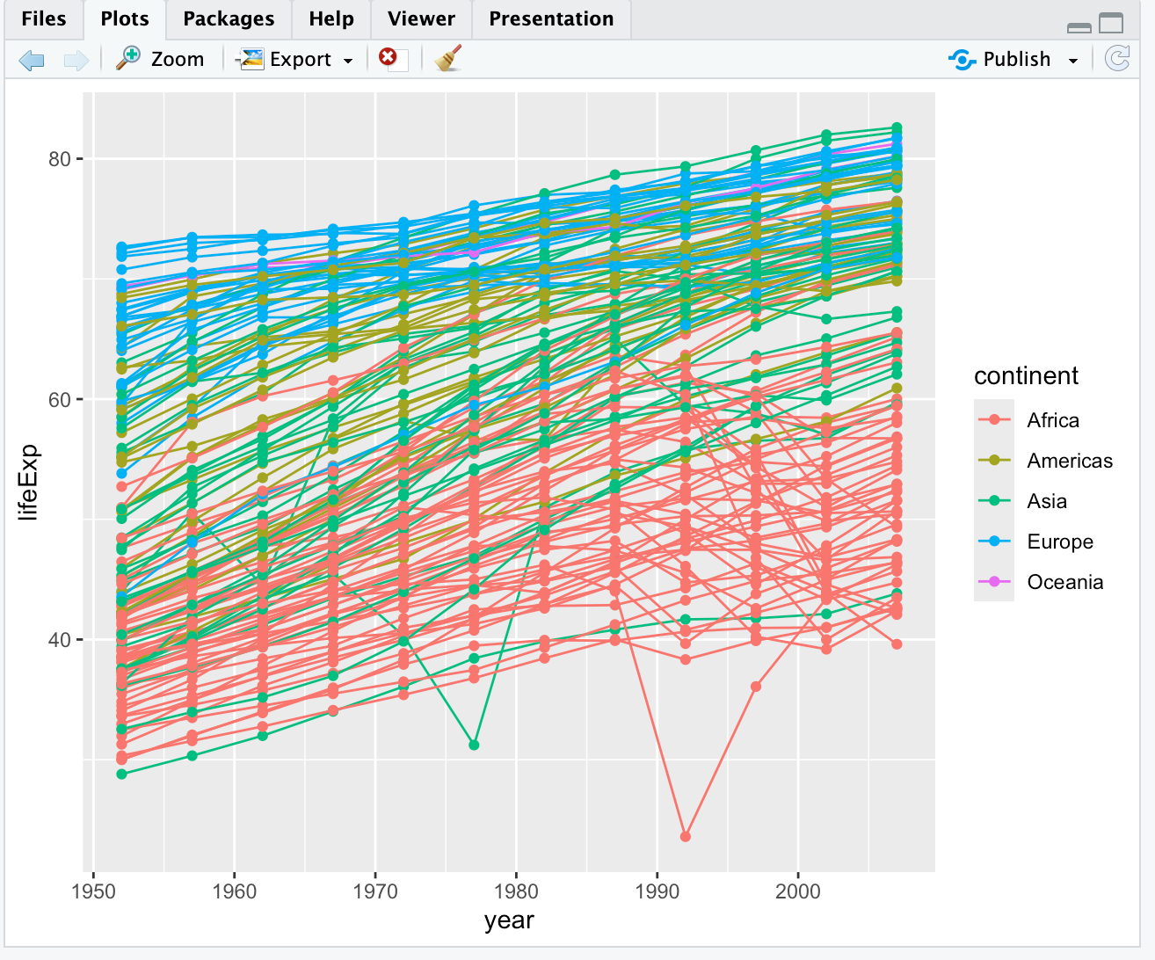

ggplot(data = gapminder, mapping = aes(x=year, y=lifeExp,

group = country)) +

geom_line(mapping = aes(color = continent)) +

geom_point() # puts color only on lines, not points - lines are behind points

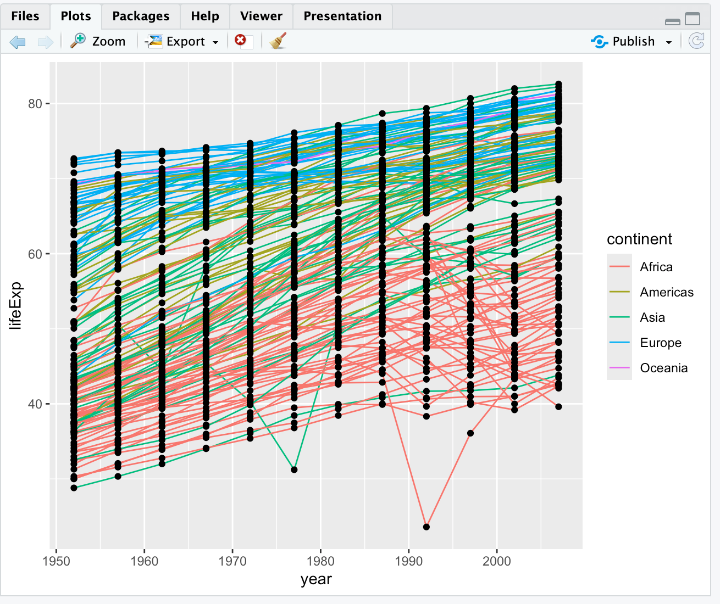

ggplot(data = gapminder, mapping = aes(x=year, y=lifeExp,

group = country)) +

geom_point() +

geom_line(mapping = aes(color = continent)) # puts lines on top of points, not behind the points

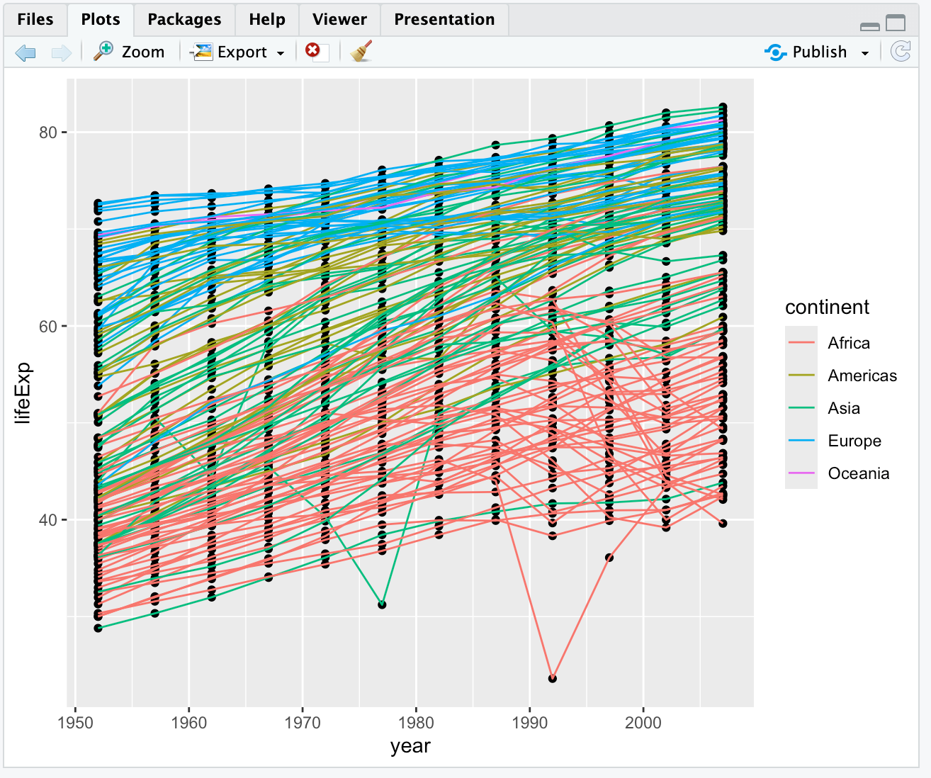

# original plot - using this graph for next exercises

ggplot(data = gapminder, mapping = aes(x=gdpPercap, y=lifeExp)) + geom_point()



# scaling and alpha

ggplot(data = gapminder, mapping = aes(x=gdpPercap, y=lifeExp)) +

geom_point(alpha = 0.5) + # setting alpha level to transform data

scale_x_log10() # transforming the x data using log10

?geom_smooth # tells you the different ways to visualize the data

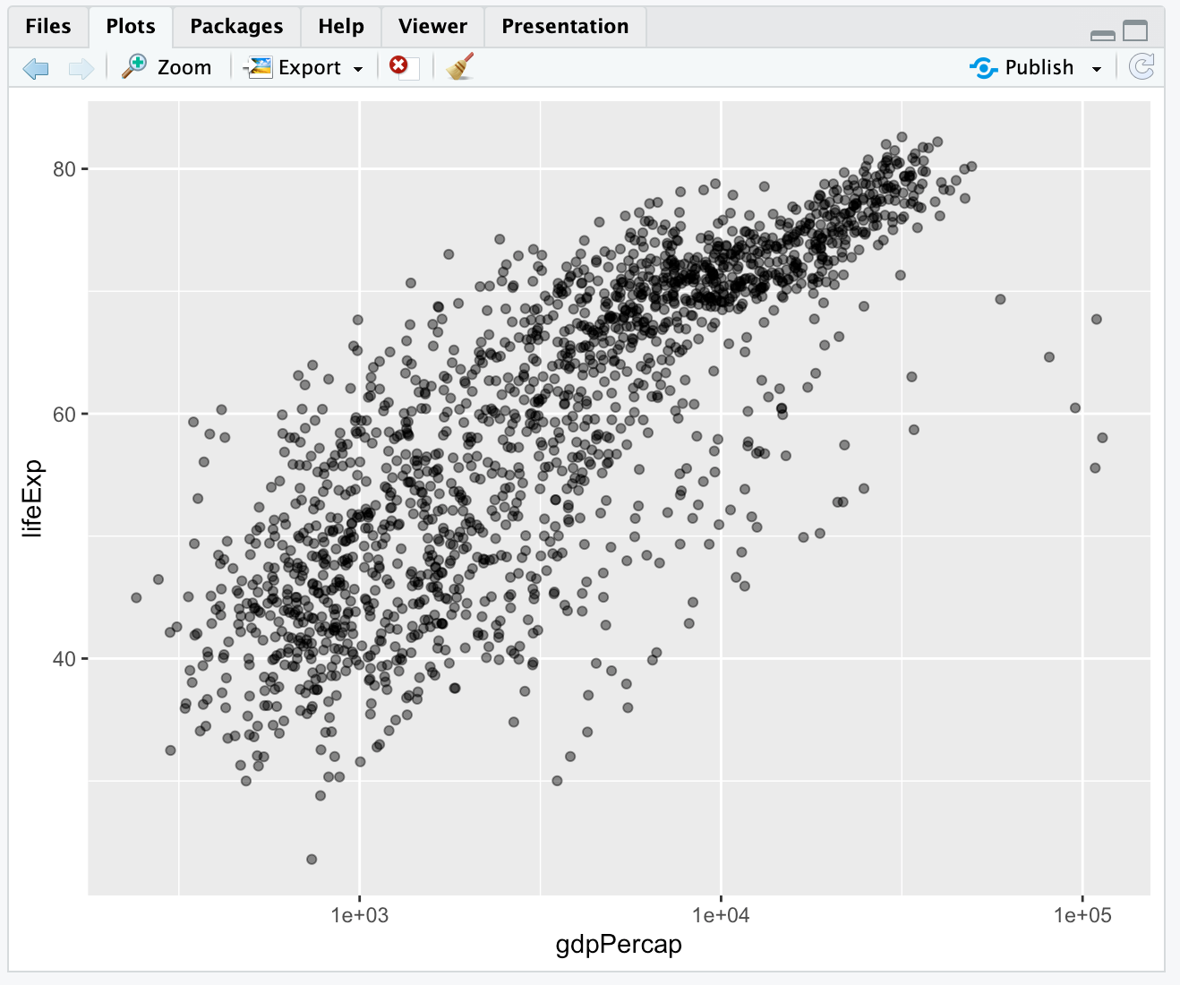

# using lm method with geom_smooth

ggplot(data = gapminder, mapping = aes(x=gdpPercap, y=lifeExp)) +

geom_point(alpha = 0.5) +

scale_x_log10() +

geom_smooth(method="lm") # gives you the line of best fit

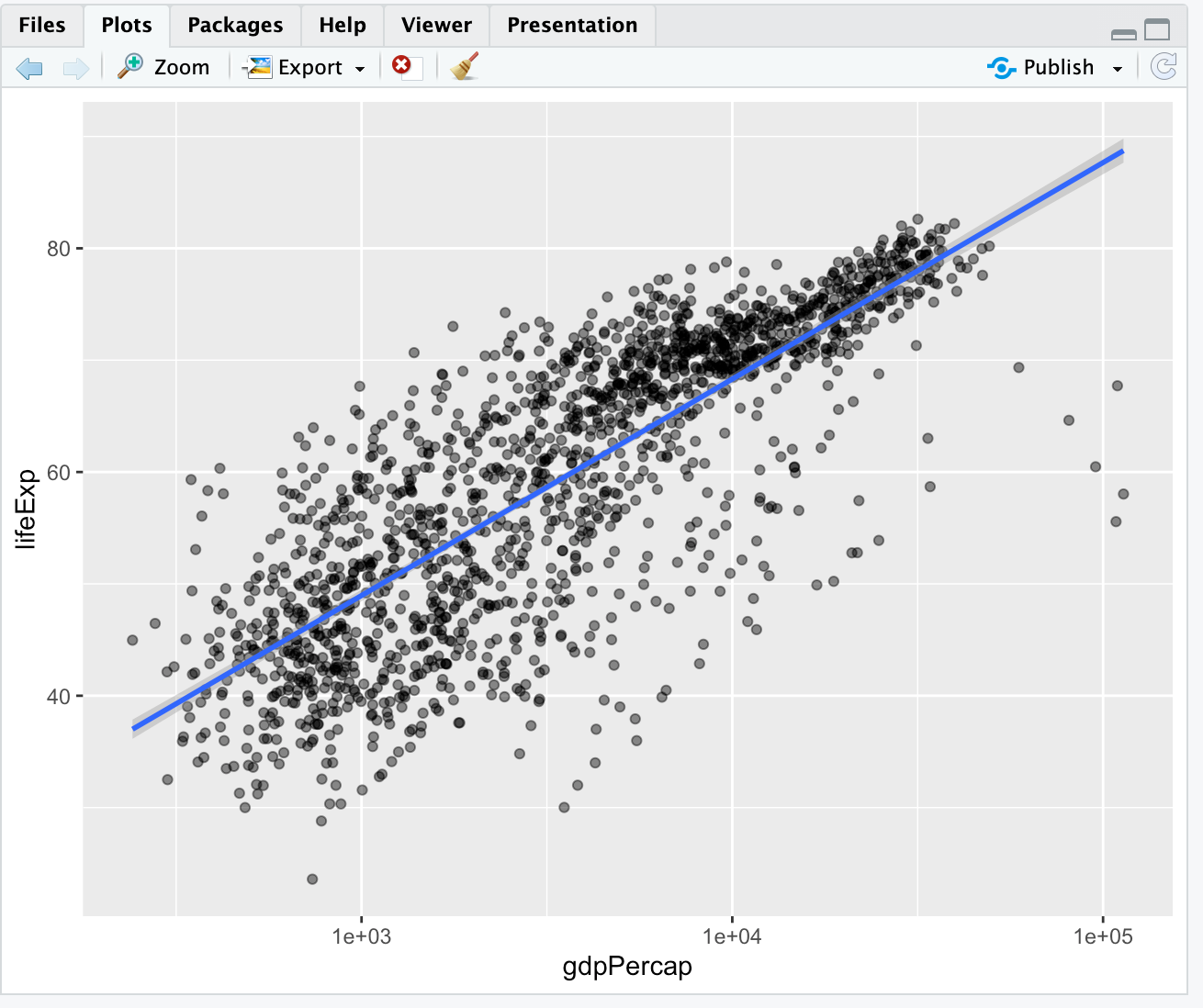

# changing the width of the line of best fit

ggplot(data = gapminder, mapping = aes(x=gdpPercap, y=lifeExp)) +

geom_point(alpha = 0.5) +

scale_x_log10() +

geom_smooth(method="lm", linewidth=1.5)

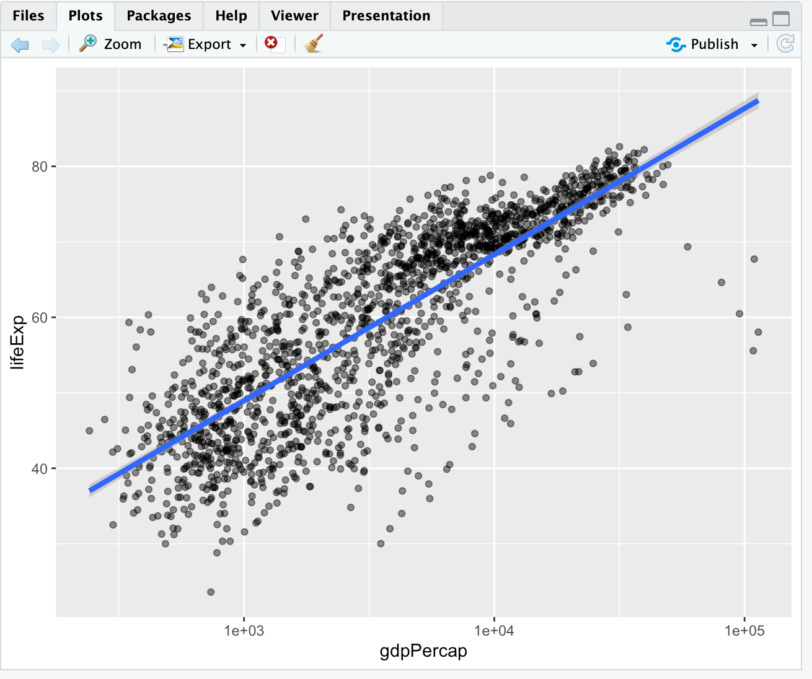

# creating a multipanel plot

# first need to subset the data

americas <- gapminder[gapminder$continent == "Americas",]

ggplot(data = americas, mapping = aes(x=year, y=lifeExp)) +

geom_line() +

facet_wrap( ~ country) + # gives you a different plot for each country in the Americas

theme(axis.text.x = element_text(angle = 45)) # changes the angle of the x-axis tick labels by 45 degrees

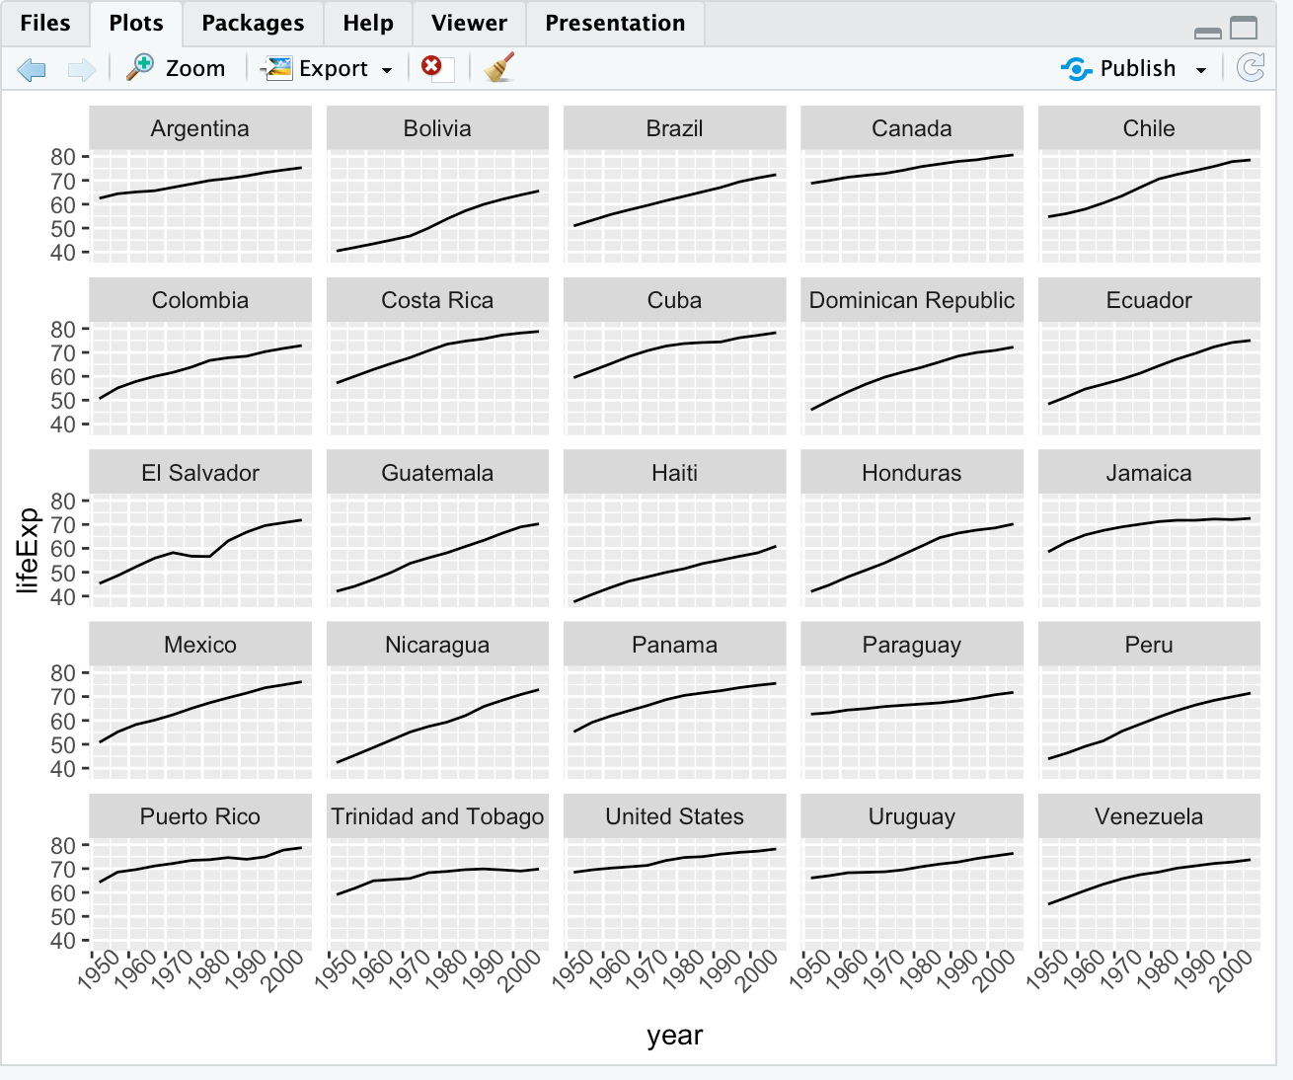

# adding labels

americas <- gapminder[gapminder$continent == "Americas",]

ggplot(data = americas, mapping = aes(x=year, y=lifeExp)) +

geom_line() +

facet_wrap( ~ country) +

theme(axis.text.x = element_text(angle = 45)) +

labs(x = "Year", y = "Life Expectancy", title = "Figure 1")

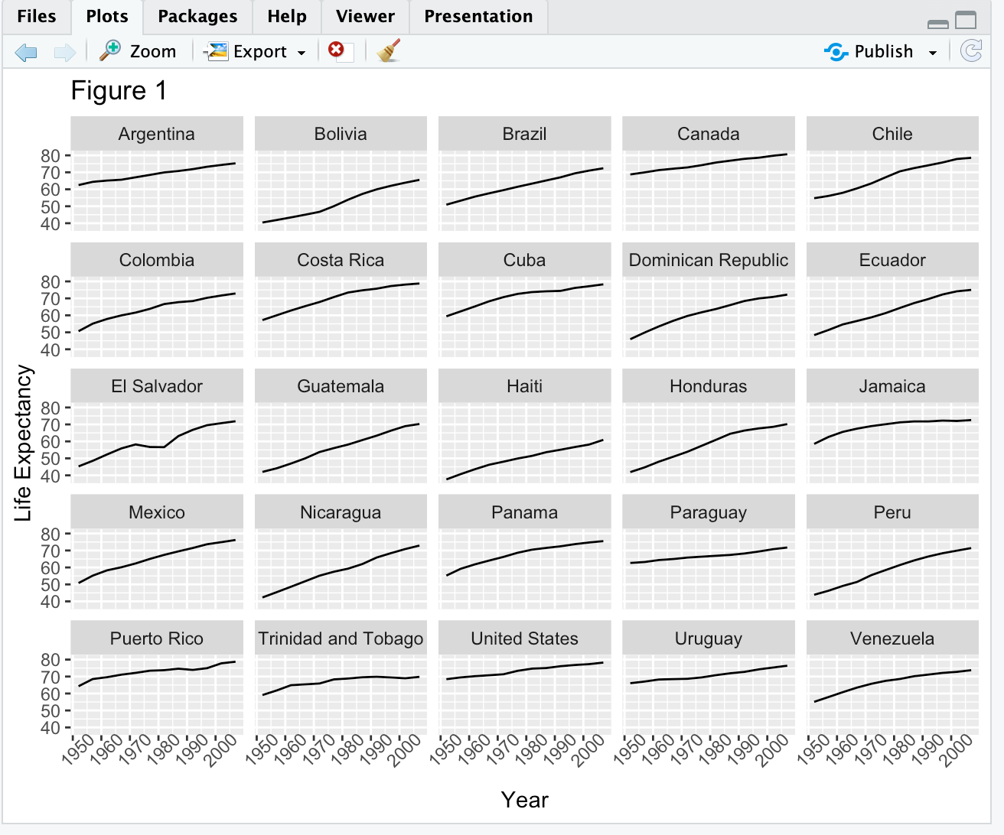

# adding color

americas <- gapminder[gapminder$continent == "Americas",]

ggplot(data = americas, mapping = aes(x=year, y=lifeExp, color = continent)) +

geom_line() +

facet_wrap( ~ country) +

theme(axis.text.x = element_text(angle = 45)) +

labs(x = "Year", y = "Life Expectancy", title = "Figure 1")

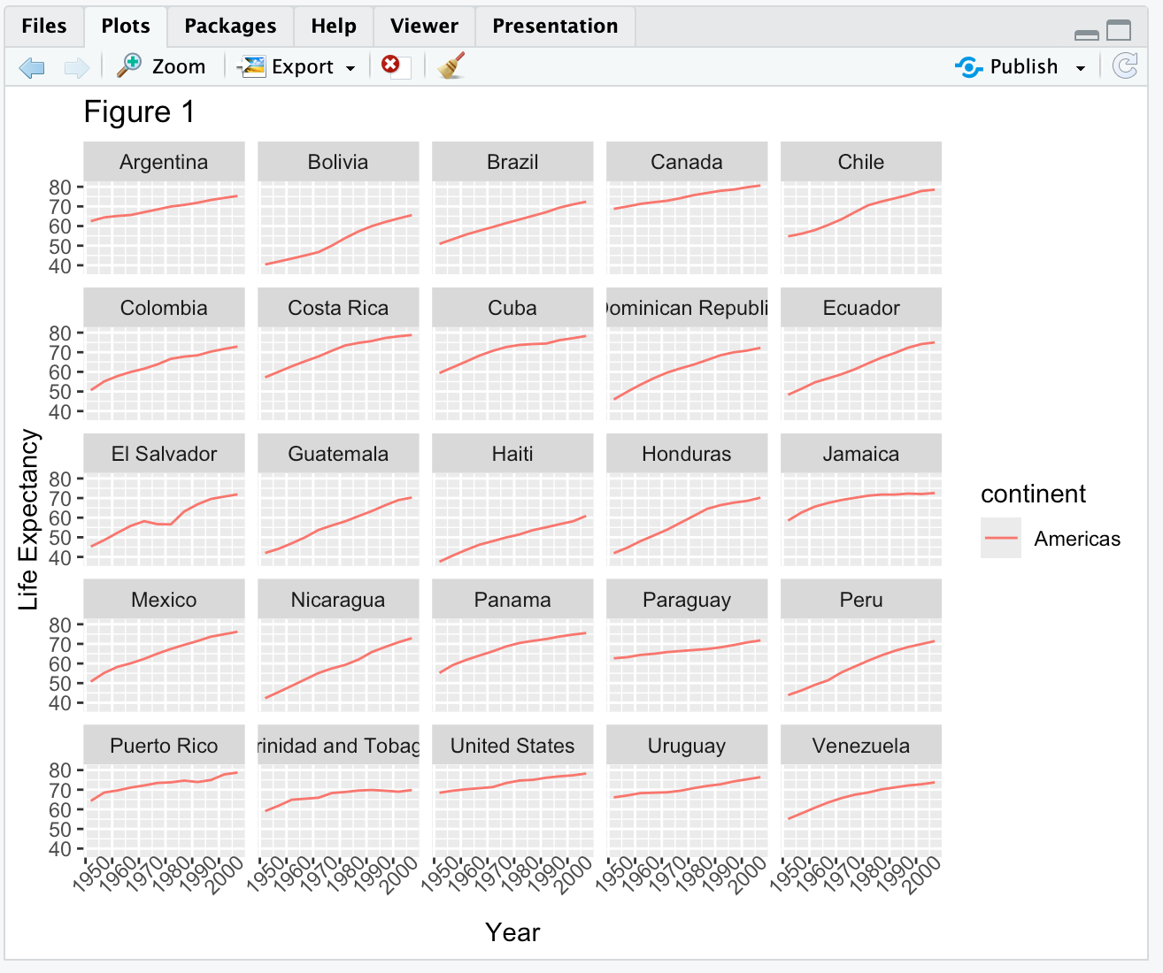

americas <- gapminder[gapminder$continent == "Americas",]

ggplot(data = americas, mapping = aes(x=year, y=lifeExp, color = continent)) +

geom_line() +

facet_wrap( ~ country) +

theme(axis.text.x = element_text(angle = 45)) +

labs(x = "Year", y = "Life Expectancy", title = "Figure 1", color = "Continent")

theme_minimal()

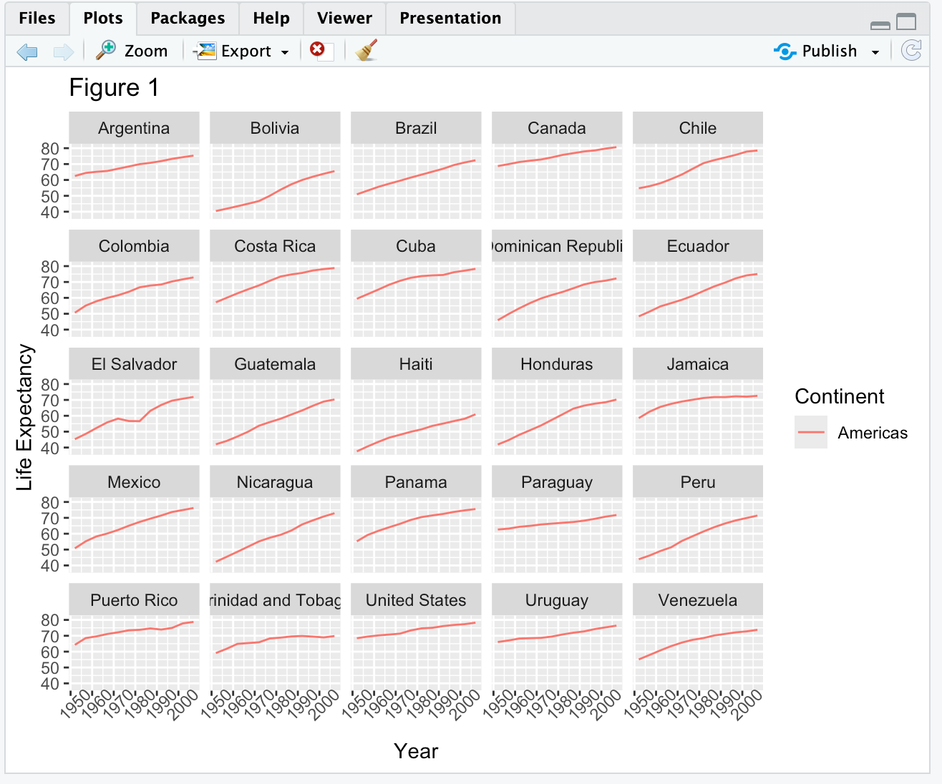

# exporting the plot

americas <- gapminder[gapminder$continent == "Americas",]

life_expect_plot <- ggplot(data = americas, mapping = aes(x=year, y=lifeExp, color = continent)) +

geom_line() +

facet_wrap( ~ country) +

theme(axis.text.x = element_text(angle = 45)) +

labs(x = "Year", y = "Life Expectancy", title = "Figure 1")

ggsave(filename = "results/life_exp.png",

plot = life_expect_plot,

width = 12,

height = 10,

dpi = 300, # sets resolution of graphic - typically want to do 450-600, but that takes time

units = "cm")

# output: filepath: workshops/analysis/results

# changing theme

life_expect_plot + theme_dark() # dark mode

# there are other themes - look them up and apply them similarly

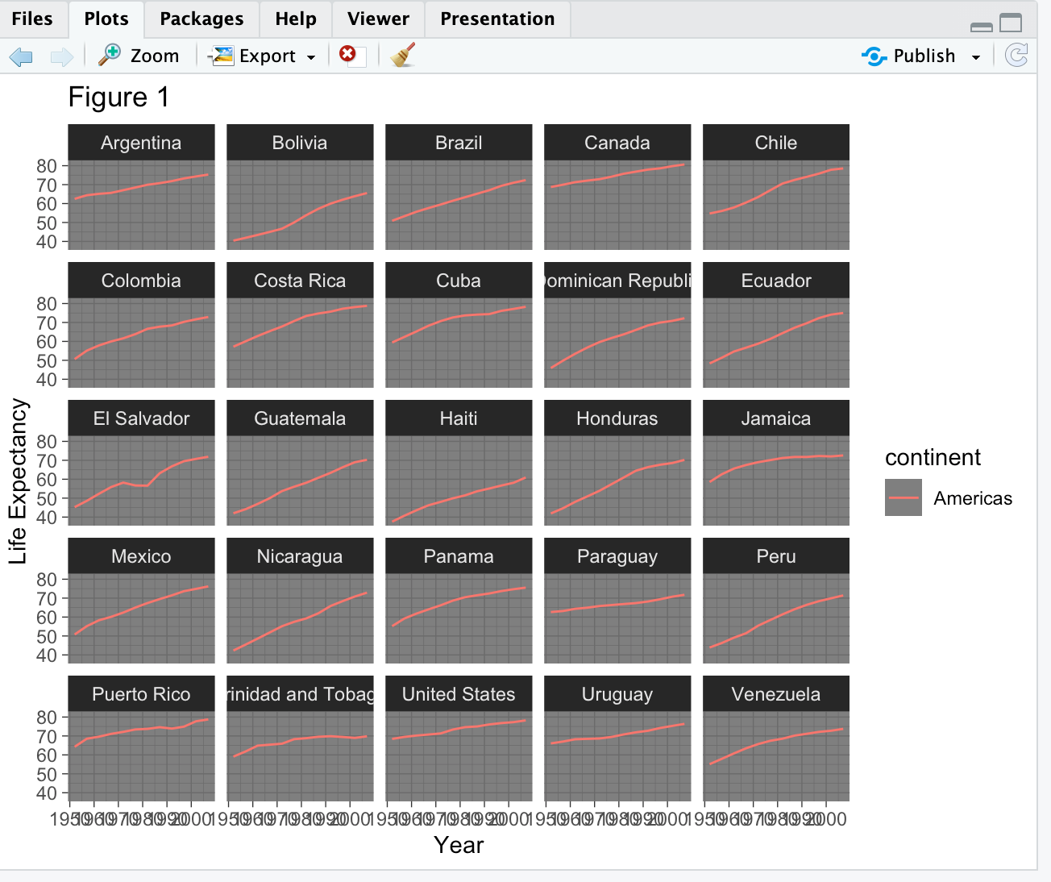

**Functions Explained**

Code used today:

# function

fahr_to_kelvin <- function(temp){

kelvin <- ((temp - 32)*(5/9)) + 273.15

return(kelvin)

}

# output in environment: function (temp)

fahr_to_kelvin(32)

# output: [1] 273.15

fahr_to_kelvin(212)

# output: [1] 373.15

#combining functions

kelvin_to_celcius <- function(temp){

celcius <- temp - 273.15

return(celcius)

}

# output in envirnoment: function (temp)

kelvin_to_celcius(300)

# output: [1] 26.85

fahr_to_celcius <- function(temp){

temp_k <- fahr_to_kelvin(temp)

temp_c <- kelvin_to_celcius(temp_k)

return(temp_c)

}

# output in environment: function (temp)

fahr_to_celcius(32)

# output: [1] 0

fahr_to_celcius(212)

# output: [1] 100

fahr_to_kelvin("a")

# gives error because a is not a number

fahr_to_kelvin("100")

# gives an error because value is in quotes, which means it's a categorical variable

fahr_to_kelvin <- function(temp) {

if(!is.numeric(temp)){

stop("temp must be a numeric factor") # if the value is not numeric, it will stop the analysis

}

kelvin <- ((temp -32)*(5/9)) + 273.15

return(kelvin)

}

fahr_to_kelvin("100")

# gives an error because "100" isn't numeric - meant to demonstrate the if statement

print("hello")

# output: [1] "hello"

fahr_to_kelvin <- function(temp){

stopifnot(is.numeric(temp))

kelvin <- ((temp-32)*(5/9))+273.15

return(kelvin)

}

fahr_to_kelvin("100")

# gives an error because "100" isn't numeric - meant to demonstrate the stopifnot statement

# complex functions

calcGDP <- function(dat){

gdp <- dat$pop*dat$gdpPercap

return(gdp)

}

head(gapminder)

calcGDP(head(gapminder))

# output: [1] 6567086330 7585448670 8758855797 9648014150 9678553274 11697659231

# adding more arguments

calcGDP <- function(dat, year = NULL, country = NULL){

if(!is.null(year)){

dat <- dat[dat$year %in% year,]

}

if(!is.null(country)){

dat <- dat[dat$country %in% country, ]

}

gdp <- dat$pop*dat$gdpPercap

new <- cbind (dat, gdp=gdp)

return(new)

}

head(calcGDP(gapminder, country = "Australia"))

# output: country year pop continent lifeExp gdpPercap gdp

# 61 Australia 1952 8691212 Oceania 69.12 10039.60 87256254102

# 62 Australia 1957 9712569 Oceania 70.33 10949.65 106349227169

# 63 Australia 1962 10794968 Oceania 70.93 12217.23 131884573002

# 64 Australia 1967 11872264 Oceania 71.10 14526.12 172457986742

# 65 Australia 1972 13177000 Oceania 71.93 16788.63 221223770658

# 66 Australia 1977 14074100 Oceania 73.49 18334.20 258037329175

head(calcGDP(gapminder, country = "Australia", year = 2007))

# output: country year pop continent lifeExp gdpPercap gdp

# 72 Australia 2007 20434176 Oceania 81.235 34435.37 703658358894

# sum 5 numbers

sum_my_numbers <- function(x){

y <- sum(x)

}

x <- c(1,2,3,5,4)

sum_my_numbers(x)

# gives no output - we didn't ask it to return anything

# solution

sum_my_numbers <- function(x){

y <- sum(x)

return(y)

}

x <- c(1,2,3,5,4)

sum_my_numbers(x)

# output: [1] 15

sum_my_numbers <- function(x){

y <- sum(x)

z <- mean(x)

yz <- c(y,z)

return(yz)

}

x <- c(1,2,3,5,4)

sum_my_numbers(x)

# output: [1] 15 3

head(gapminder)

# output: country year pop continent lifeExp gdpPercap

# 1 Afghanistan 1952 8425333 Asia 28.801 779.4453

# 2 Afghanistan 1957 9240934 Asia 30.332 820.8530

# 3 Afghanistan 1962 10267083 Asia 31.997 853.1007

# 4 Afghanistan 1967 11537966 Asia 34.020 836.1971

# 5 Afghanistan 1972 13079460 Asia 36.088 739.9811

# 6 Afghanistan 1977 14880372 Asia 38.438 786.1134

unique(gapminder$country) # tells you every country in the dataset - there are too many to paste here

**Writing Data (aka Saving Plots)**

Code used today:

library(ggplot2)

ggplot(gapminder,

aes(x = year, y = lifeExp, color = country)) +

geom_line() +

theme(legend.position = "none")

# save most recent ggplot

ggsave("most_recent_gapminder+plot.pdf")

# then follow gui instructions

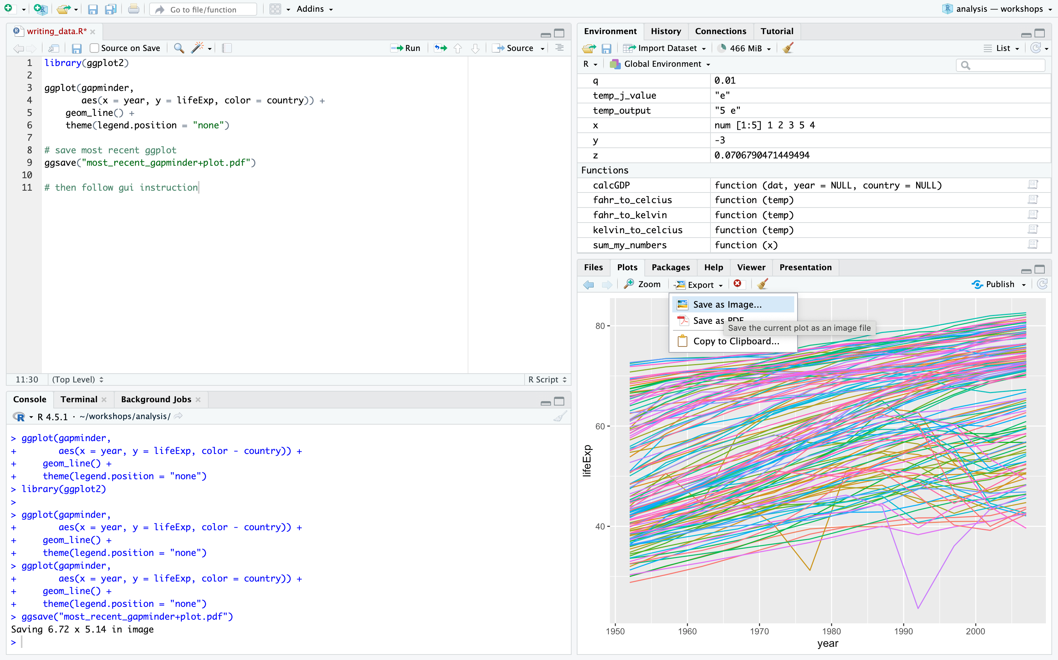

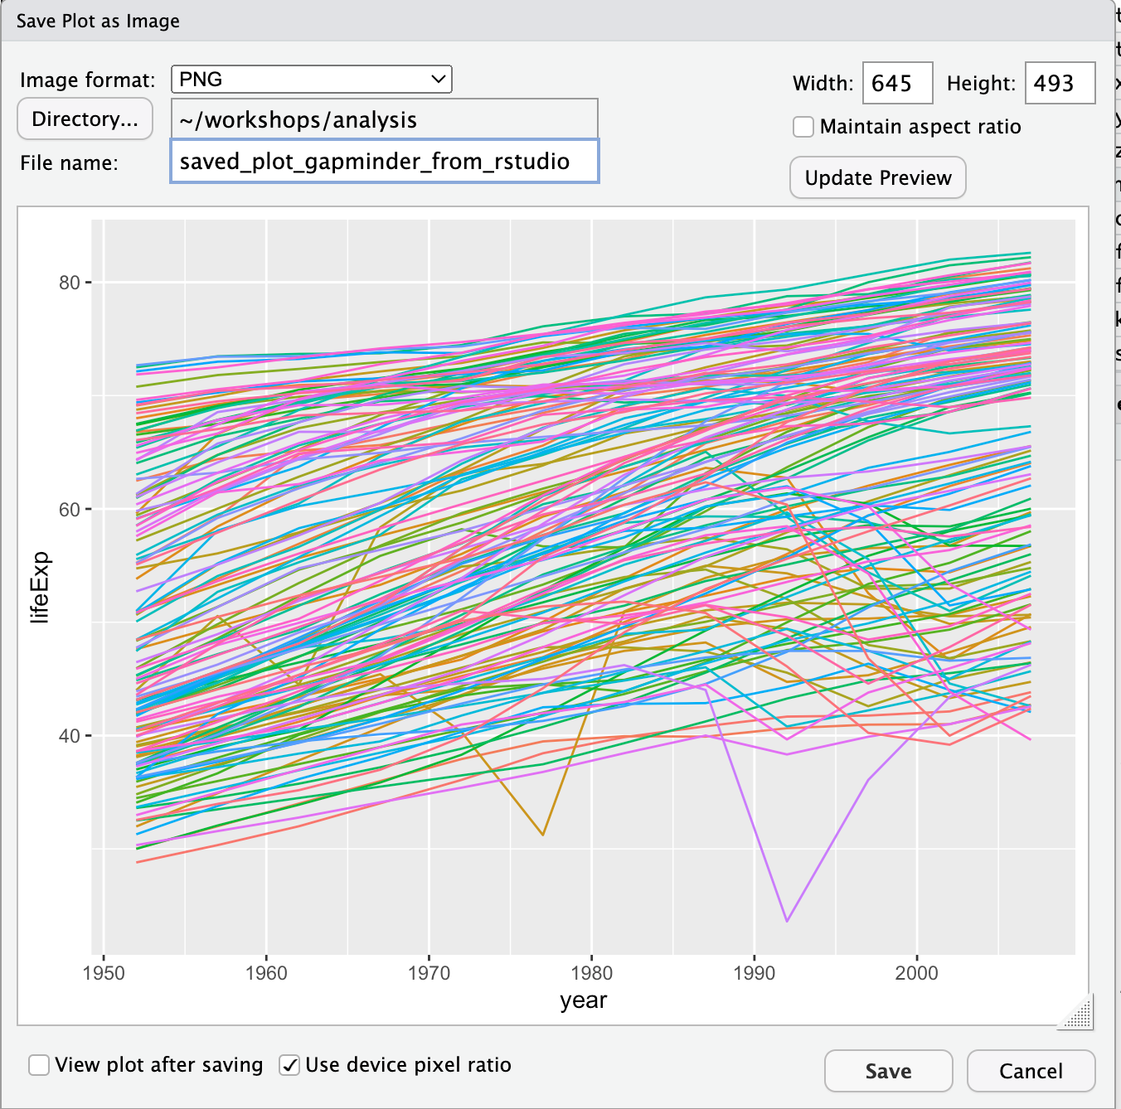

# save as pdf

pdf("plot_from_function_pdf_gapminder.pdf",

width = 12, height = 4) # creates blank pdf file

ggplot(gapminder,

aes(x = year, y = lifeExp, color = country)) +

geom_line() +

theme(legend.position = "none") # creates plot

dev.off() # saves plot to pdf file

pdf("plot_from_func_pdf_gapminder_2.pdf",

width = 12,

height = 4,

pointsize = 12,

family = "sans")

ggplot(gapminder,

aes(x = year, y = lifeExp, color = country)) +

geom_line() +

theme(legend.position = "none")

dev.off()

# creating multiple plots in one pdf

pdf("multipage.pdf", width = 10, height = 6)

plot (x = 1:10, y = 1:10)

plot (x = 1:10, y = (1:10)^2)

plot (x = 1:10, y = sqrt(1:10))

dev.off()

svg()

jpeg()

png()

aust_subset <- gapminder[gapminder$country == "Australia",]

head(aust_subset)

dim(aust_subset)

write.csv(aust_subset,

file = "data/gapminder_aust_subset.csv",

row.names = FALSE,

quote = FALSE)

write.table(aust_subset,

file = "data/gapminder_aust_subset_from_write.csv",

sep = ",")

# other options to save data

library(readxl)

WriteXLS::WriteXLS()

library(haven)

write_sas(df, "location")

#reading the file

gapminder_australia_read_dt <- read.csv("data/gapminder_aust_subset.csv")

**Data Frame Manipulation with dplyr**

Code used today:

library(dplyr)

gapminder <- read.csv("data/gapminder_data.csv")

# running the mean gdp for individual continents

mean(gapminder$gdpPercap[gapminder$continent == "Africa"]) # gets the gdp for certain continents (i.e., Africa)

# output: [1] 2193.755

mean(gapminder$gdpPercap[gapminder$continent == "Americas"])

# output: [1] 7136.11

# select a column

year_country_gdp <- dplyr::select(gapminder, year, country, gdpPercap)

head(year_country_gdp)

# output: year country gdpPercap

# 1 1952 Afghanistan 779.4453

# 2 1957 Afghanistan 820.8530

# 3 1962 Afghanistan 853.1007

# 4 1967 Afghanistan 836.1971

# 5 1972 Afghanistan 739.9811

# 6 1977 Afghanistan 786.1134

# remove a column

smaller_gapminder_data <- select(gapminder, -continent)

head(smaller_gapminder_data)

# output: country year pop lifeExp gdpPercap

# 1 Afghanistan 1952 8425333 28.801 779.4453

# 2 Afghanistan 1957 9240934 30.332 820.8530

# 3 Afghanistan 1962 10267083 31.997 853.1007

# 4 Afghanistan 1967 11537966 34.020 836.1971

# 5 Afghanistan 1972 13079460 36.088 739.9811

# 6 Afghanistan 1977 14880372 38.438 786.1134

year_country_gdp <- gapminder %>% select(year, country, gdpPercap)

head(year_country_gdp)

# output: year country gdpPercap

# 1 1952 Afghanistan 779.4453

# 2 1957 Afghanistan 820.8530

# 3 1962 Afghanistan 853.1007

# 4 1967 Afghanistan 836.1971

# 5 1972 Afghanistan 739.9811

# 6 1977 Afghanistan 786.1134

# rename a column

tidy_gdp <- year_country_gdp %>% rename(gdp_per_capita = gdpPercap)

head(tidy_gdp)

# output: year country gdp_per_capita

# 1 1952 Afghanistan 779.4453

# 2 1957 Afghanistan 820.8530

# 3 1962 Afghanistan 853.1007

# 4 1967 Afghanistan 836.1971

# 5 1972 Afghanistan 739.9811

# 6 1977 Afghanistan 786.1134

# filter

year_country_gdp_euro <- gapminder %>%

filter(continent == "Europe") %>%

select(year, country, gdpPercap)

head(year_country_gdp_euro)

# output: year country gdpPercap

# 1 1952 Albania 1601.056

# 2 1957 Albania 1942.284

# 3 1962 Albania 2312.889

# 4 1967 Albania 2760.197

# 5 1972 Albania 3313.422

# 6 1977 Albania 3533.004

year_country_lifeExp_euro_2007 <- gapminder %>%

filter(continent == "Europe", year == 2007) %>%

select(country, lifeExp)

head(year_country_lifeExp_euro_2007)

# output: country lifeExp

# 1 Albania 76.423

# 2 Austria 79.829

# 3 Belgium 79.441

# 4 Bosnia and Herzegovina 74.852

# 5 Bulgaria 73.005

# 6 Croatia 75.748

# group_by() function

str(gapminder)

# output: 'data.frame': 1704 obs. of 6 variables:

# $ country : chr "Afghanistan" "Afghanistan" "Afghanistan" "Afghanistan" ...

# $ year : int 1952 1957 1962 1967 1972 1977 1982 1987 1992 1997 ...

# $ pop : num 8425333 9240934 10267083 11537966 13079460 ...

# $ continent: chr "Asia" "Asia" "Asia" "Asia" ...

# $ lifeExp : num 28.8 30.3 32 34 36.1 ...

# $ gdpPercap: num 779 821 853 836 740 ...

str(gapminder %>% group_by(continent))

# output: gropd_df [1,704 × 6] (S3: grouped_df/tbl_df/tbl/data.frame)

# $ country : chr [1:1704] "Afghanistan" "Afghanistan" "Afghanistan" "Afghanistan" ...

# $ year : int [1:1704] 1952 1957 1962 1967 1972 1977 1982 1987 1992 1997 ...

# $ pop : num [1:1704] 8425333 9240934 10267083 11537966 13079460 ...

# $ continent: chr [1:1704] "Asia" "Asia" "Asia" "Asia" ...

# $ lifeExp : num [1:1704] 28.8 30.3 32 34 36.1 ...

# $ gdpPercap: num [1:1704] 779 821 853 836 740 ...

# - attr(*, "groups")= tibble [5 × 2] (S3: tbl_df/tbl/data.frame)

# ..$ continent: chr [1:5] "Africa" "Americas" "Asia" "Europe" ...

# ..$ .rows : list<int> [1:5]

# .. ..$ : int [1:624] 25 26 27 28 29 30 31 32 33 34 ...

# .. ..$ : int [1:300] 49 50 51 52 53 54 55 56 57 58 ...

# .. ..$ : int [1:396] 1 2 3 4 5 6 7 8 9 10 ...

# .. ..$ : int [1:360] 13 14 15 16 17 18 19 20 21 22 ...

# .. ..$ : int [1:24] 61 62 63 64 65 66 67 68 69 70 ...

# .. ..@ ptype: int(0)

# ..- attr(*, ".drop")= logi TRUE

gdp_by_continent <- gapminder %>%

group_by(continent) %>%

summarize(mean_gdpPercap = mean(gdpPercap))

gdp_by_continent

# output: continent mean_gdpPercap

# <chr> <dbl>

# 1 Africa 2194.

# 2 Americas 7136.

# 3 Asia 7902.

# 4 Europe 14469.

# 5 Oceania 18622.

# group_by() multiple variables

gdp_by_continent_by_year <- gapminder %>%

group_by(continent, year) %>%

summarize(mean_gdpPercap = mean(gdpPercap))

gdp_by_continent_by_year

# output: continent year mean_gdpPercap

# <chr> <int> <dbl>

# 1 Africa 1952 1253.

# 2 Africa 1957 1385.

# 3 Africa 1962 1598.

# 4 Africa 1967 2050.

# 5 Africa 1972 2340.

# 6 Africa 1977 2586.

# 7 Africa 1982 2482.

# 8 Africa 1987 2283.

# 9 Africa 1992 2282.

# 10 Africa 1997 2379.

# calculate multiple summary statistics

gdp_pop_by_continent_by_year <- gapminder %>%

group_by(continent, year) %>%

summarize(mean_gdpPercap = mean(gdpPercap),

sd_gdpPercap = sd(gdpPercap),

mean_pop = mean(pop),

sd_pop = sd(pop))

gdp_pop_by_continent_by_year

# output: continent year mean_gdpPercap sd_gdpPercap mean_pop sd_pop

# <chr> <int> <dbl> <dbl> <dbl> <dbl>

# 1 Africa 1952 1253. 983. 4570010. 6317450.

# 2 Africa 1957 1385. 1135. 5093033. 7076042.

# 3 Africa 1962 1598. 1462. 5702247. 7957545.

# 4 Africa 1967 2050. 2848. 6447875. 8985505.

# 5 Africa 1972 2340. 3287. 7305376. 10130833.

# 6 Africa 1977 2586. 4142. 8328097. 11585184.

# 7 Africa 1982 2482. 3243. 9602857. 13456243.

# 8 Africa 1987 2283. 2567. 11054502. 15277484.

# 9 Africa 1992 2282. 2644. 12674645. 17562719.

# 10 Africa 1997 2379. 2821. 14304480. 19873013.

# count() and n()

gapminder %>%

filter(year == 2002) %>%

count(continent, sort = TRUE)

# output: continent n

# 1 Africa 52

# 2 Asia 33

# 3 Europe 30

# 4 Americas 25

# 5 Oceania 2

gapminder %>%

group_by(continent) %>%

summarize(se_lifeExp = sd(lifeExp)/sqrt(n())) # calculate standard error for life expectancy across each continent

# output: continent se_lifeExp

# <chr> <dbl>

# 1 Africa 0.366

# 2 Americas 0.540

# 3 Asia 0.596

# 4 Europe 0.286

# 5 Oceania 0.775

# mutate()

gdp_pop_by_continent_by_year <- gapminder %>%

mutate(gdp_billion = gdpPercap*pop/10^9) %>%

group_by(continent, year) %>%

summarize(mean_gdpPercap = mean(gdpPercap),

sd_gdpPercap = sd(gdpPercap),

mean_pop = mean(pop),

sd_pop = sd(pop),

mean_gdpPerbillion = mean(gdp_billion),

sd_gdpPerbillion = sd(gdp_billion))

head(gdp_pop_by_continent_by_year)

# output: continent year mean_gdpPercap sd_gdpPercap mean_pop sd_pop mean_gdpPerbillion sd_gdpPerbillion

# <chr> <int> <dbl> <dbl> <dbl> <dbl> <dbl> <dbl>

# 1 Africa 1952 1253. 983. 4570010. 6.32e6 5.99 11.4

# 2 Africa 1957 1385. 1135. 5093033. 7.08e6 7.36 14.5

# 3 Africa 1962 1598. 1462. 5702247. 7.96e6 8.78 17.2

# 4 Africa 1967 2050. 2848. 6447875. 8.99e6 11.4 23.2

# 5 Africa 1972 2340. 3287. 7305376. 1.01e7 15.1 30.4

# 6 Africa 1977 2586. 4142. 8328097. 1.16e7 18.7 38.1

# combining ifelse with mutate

gdp_pop_by_continent_by_year_leabove25 <- gapminder %>%

mutate(gdp_billion = ifelse(lifeExp > 25, gdpPercap*pop/10^9, NA)) %>%

group_by(continent, year) %>%

summarize(mean_gdpPercap = mean(gdpPercap),

sd_gdpPercap = sd(gdpPercap),

mean_pop = mean(pop),

sd_pop = sd(pop),

mean_gdpPerbillion = mean(gdp_billion),

sd_gdpPerbillion = sd(gdp_billion))

head(gdp_pop_by_continent_by_year_leabove25)

# output: continent year mean_gdpPercap sd_gdpPercap mean_pop sd_pop mean_gdpPerbillion sd_gdpPerbillion

# <chr> <int> <dbl> <dbl> <dbl> <dbl> <dbl> <dbl>

# 1 Africa 1952 1253. 983. 4570010. 6.32e6 5.99 11.4

# 2 Africa 1957 1385. 1135. 5093033. 7.08e6 7.36 14.5

# 3 Africa 1962 1598. 1462. 5702247. 7.96e6 8.78 17.2

# 4 Africa 1967 2050. 2848. 6447875. 8.99e6 11.4 23.2

# 5 Africa 1972 2340. 3287. 7305376. 1.01e7 15.1 30.4

# 6 Africa 1977 2586. 4142. 8328097. 1.16e7 18.7 38.1

# combining ggplot and dplyr

library(ggplot2)

gapminder %>%

filter(continent == "Americas") %>%

ggplot(mapping = aes(x=year, y=lifeExp)) +

geom_line() +

facet_wrap( ~ country) +

theme(axis.text.x = element_text(angle = 45))

**Producing Reports with knitr**

Code used today:

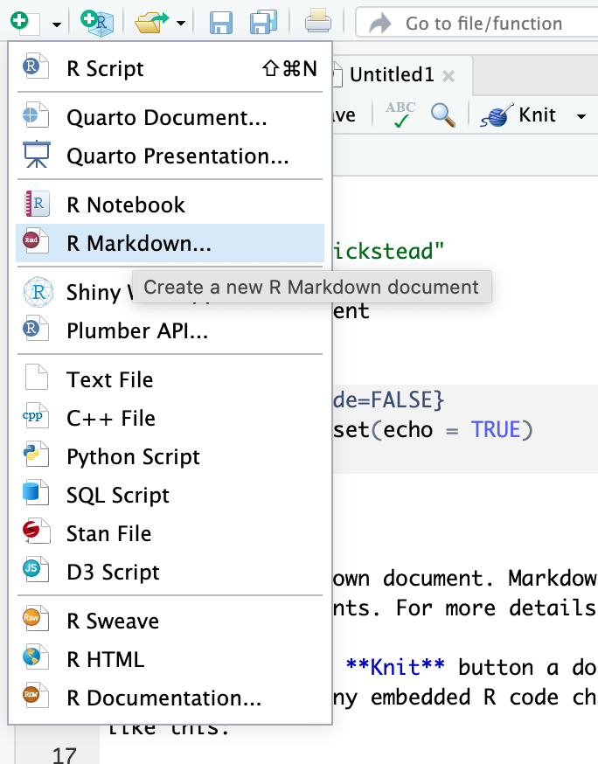

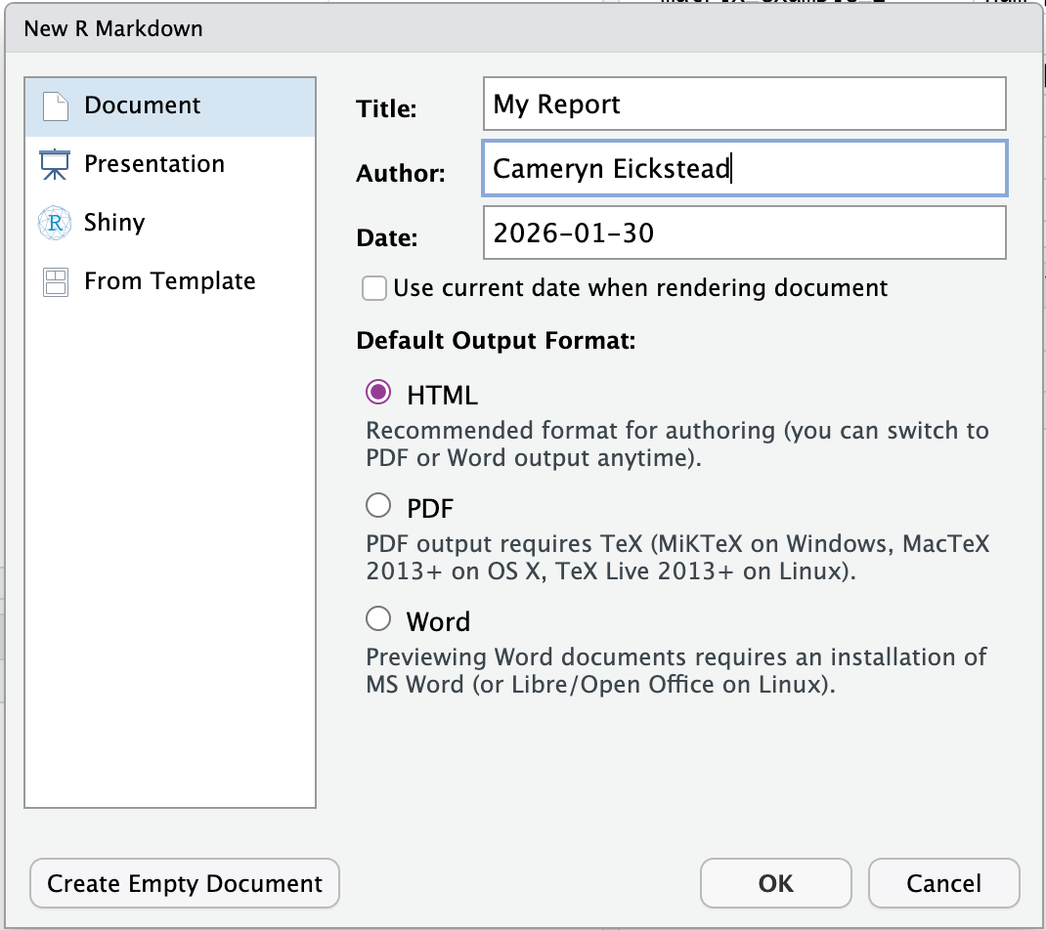

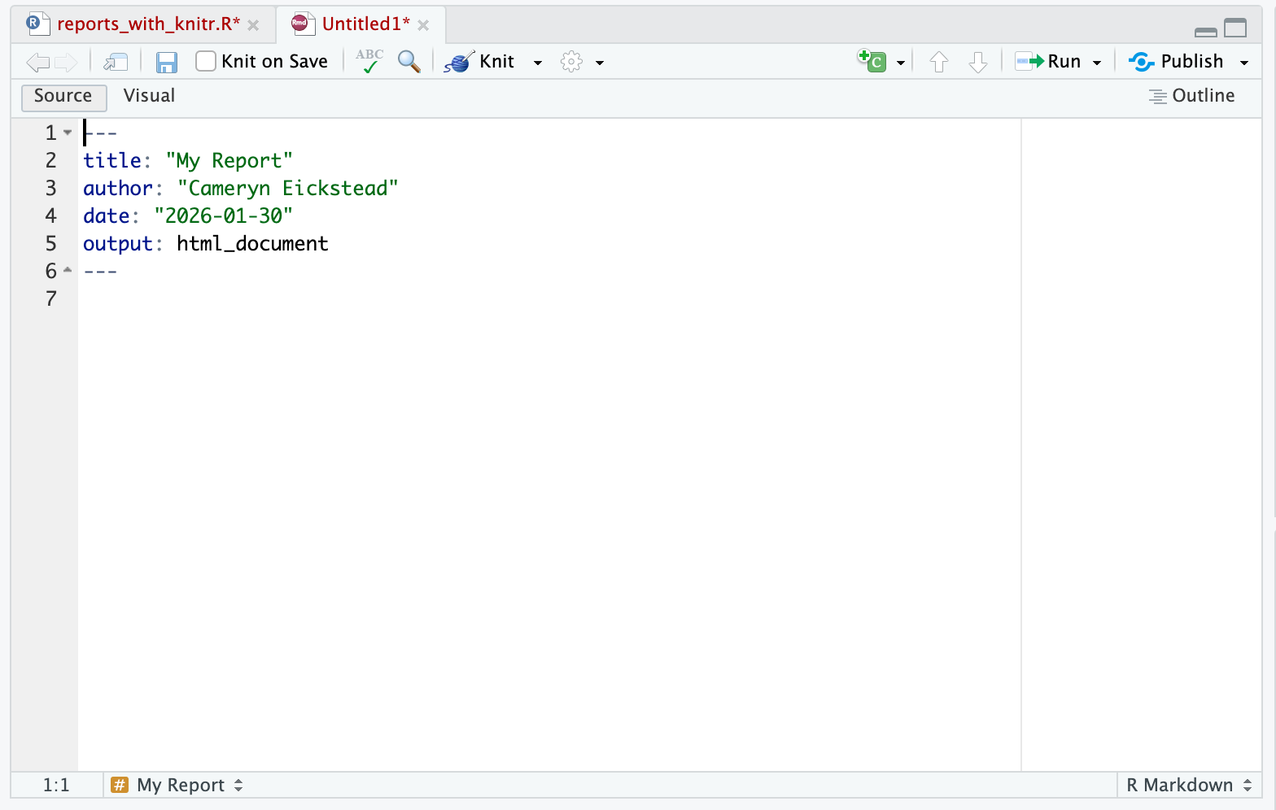

---

title: "My Report"

author: "Cameryn Eickstead"

date: "2026-01-30"

output: html_document

---

*This is an italicized list*

**This is a bold list**

# This is a heading

## This is a sub-heading

##### This is a sub-sub-heading

## This is another sub-heading

We can make lists

* This is item #1

* This is item #2

* This is item #3

We can make numbered lists

1. This is item #1

2. This is item #2

3. This is item #3

This is also a numbered list

1. This is item #1

1. This is subitem #1

1. This is subitem #2

1. This is item #2

1. This is item #3

```{r load_data}

library("ggplot2")

gapminder <- read.csv("../data/gapminder_data.csv")

```

```{r plot}

ggplot(data = gapminder,

mapping = aes(x = gdpPercap, y = lifeExp)) +

geom_point()

```

